The Incredible Journe$ of the

ALOAT-Bird

Follow this 1956 Ford Thunderbird as it  
crosses the country in search of it’s  
NEW OWNER (It could be YOU!)

**PLUS!**

**Holu** RLOR Members haue helped Hurricane Suruiuors  
Concealed Ouerhead Door Closer  
Jail Locks

Institutional Locks at Thomas Jefferson School  
Marketing Vour Products and Seruices  
Time Lock Seruicing Fundamentals Reuieuj

2-OI GIT 303

Breck H. Camp Cml PO Box 47070 Atlanta GA 30362-0070

**IiiIIiIIiiiiiMiiIIiiiiIiMIiiiIIiiiIiiiIIIiiiIiiiIIIimiiIiII**

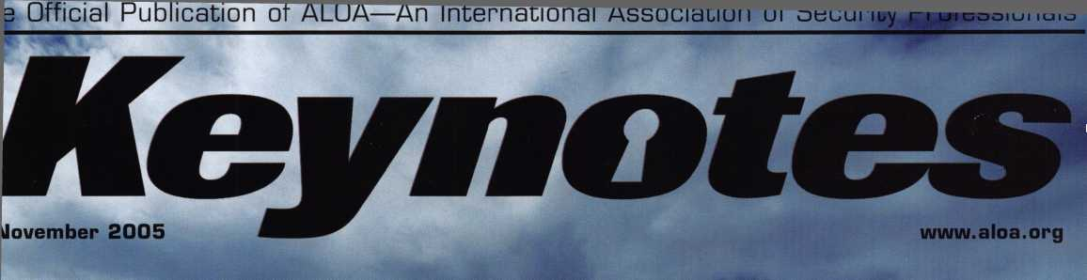

OUR STAND

IT’S QUITE POSSIBLY YOUR MOST

**TRUSTED SIDEKICK.**

**service mark and "Our Stand" is a service mark of Allstate Insurance Company. ©2005**

**npany, Irving, TX. Allstate New Jersey Insurance Jlstate Insurance Company, Northbrook, IL.**

Keep it in Good Hands® with Allstate.

As a small business owner, there are few things you rely on more than your vehicle to keep you going. Your local Allstate agent can help protect it and your small business with services you need including

quick certificates of insurance, ID cards, assistance with the claims process, and more. All from one of the most widely recognized names in the business

Are you in Good Hands®?

1-800-859-0247

CALL NOW TO LOCATE YOUR NEARBY ALLSTATE AGENT.

**/instate**

You re in good hands

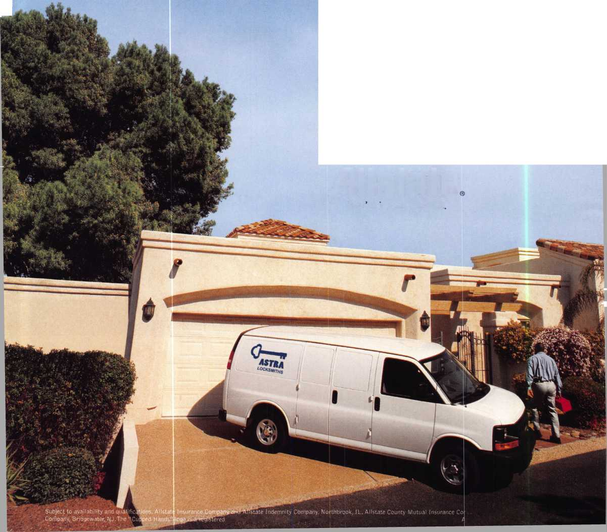

**A** Name You Know

As a business owner, you know the importance of a  
good name. Your name is your reputation. Your name  
stands for all that you offer in products and services.  
It’s a symbol of who you are. So, we thought you  
might like to know that Allstate, the name you know  
for insuring your personal vehicle and your home,  
also offers a business auto policy to help protect vehi-  
cles used in your locksmith business.

The following are coverages typically included in  
our business auto policy that might be important to  
you as a business owner:

Business Auto Liability coverage

* Higher limits up to $2,000,000 per occur-  
  rence.
* Protects you if you are legally responsible  
  for injuries and damages arising out of  
  the ownership, maintenance, or use of  
  business vehicles.
* Cost is based on several factors, including  
  garage location, type and use of vehicle,  
  and the violation and accident activity of  
  your drivers.
* Additional Insured coverage may be  
  required when you contract with govern-  
  mental agencies or bid on local  
  commercial jobs.
* Generally not available on a personal auto  
  policy.
* Usually is no charge to add an insured to  
  a Commercial Auto policy.

Hired Auto coverage

* Provides liability coverage for those  
  vehicles you rent, hire or borrow for  
  business use.
* The premium for hired auto liability  
  coverage is based on the estimated  
  annual rental cost.
* Tools and Special Equipment
* Provides protection to permanently  
  attached equipment on your vehicle.
* You will need to let your agent know the  
  value of the equipment to include in the  
  cost of the vehicle.

You’re good at your business. Your insurance com-  
pany should be the same way.

Contact an Allstate agent to discuss your business  
auto insurance needs. To be referred to an agent,  
please call 800.859.0247 or email

**[abisO@allstate.com](mailto:abisO@allstate.com)**.

Subject to availability and qualifications. Insurance coverage  
is subject to policy terms.

Allstate Insurance Company

Allstate Indemnity Company  
Northbrook, IL

Allstate County Mutual Insurance Company  
Irving, TX

Allstate New Jersey Insurance Company  
Bridgewater, NJ

allstate.com

© 2005 Allstate Insurance Company, Northbrook, IL

BETTER  
THAN EVER.

This Hawkeye® Borescope

includes all of the latest upgrades for safe and vault professionals: Optics that deliver images that rival German scopes. A new mirror technology that resists scratches from insulation, asbestos, and burrs. And a mirror protection sleeve to ward off dust.

Plus the option of the  
GRAND KIT with a fully  
configured 7” and 17”  
scope in one case. Or the  
economy minded LE model.

The red eyecup tells you  
that you have the scope  
made specifically for safe  
and vault professionals.

Available from Gradient Lens resellers to the safe and vault industry only.

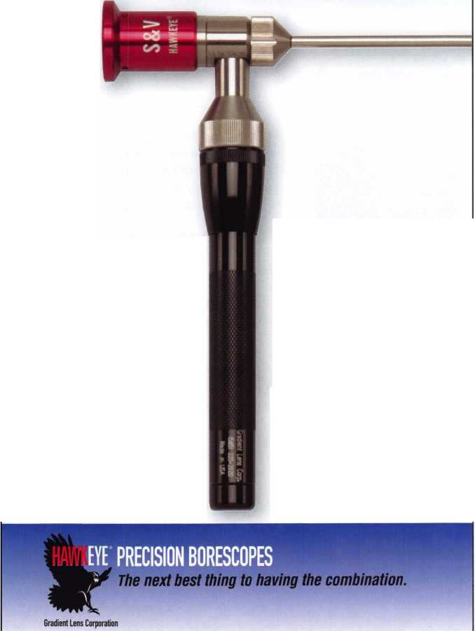

|  |  |  |
| --- | --- | --- |
| p r e s i d < | 3 n t i | ◦ 1 |
| v i e w p | o i n | t |

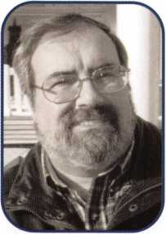

Dear Members,

commitment- 1. Act of committing; state of being committed; consignment. 2. Act of doing or performing some­thing; commission. 3. A promise or pledge to do something. 4. The act of devoting oneself.

Last month I had the honor of being the keynote speaker at the Institutional Locksmiths7 Association's banquet. The theme of their convention was "Unity77 and I was asked to give my thoughts on the subject. If "Unity", with all its benefits is to be achieved, there are three essentials that must be present: communication, cooperation, and com­mitment. It is only when a group of individuals combines these powerful forces can effective work be accomplished to the benefit of all concerned.

In the past two messages I have written about communication and cooperation. Now let's focus on commitment. Perhaps this is the most difficult area because it demands a great deal from each individual and covers a broad spectrum.

It is of primary importance to have a commitment to oneself. A person gets nowhere in life if he is not a person of conviction and commitment. He needs to set goals and do everything in his power to attain those goals. Goals are myriad; it is up to the individual what will compose his life's work and which goals will make him happy. This is where commitment comes in. If he is truly serious, then continual action must follow to attain the prize. As a secu­rity professional, it is important to be trustworthy and honest. The general public seeks an individual who "does as he says" and meets deadlines. With this said, it follows that a person's business will grow and prosper because of his commitment.

Next, there is the commitment to one's vocation or trade. To do any work, one needs tools and those tools must be used. Though important, I'm not speaking of the physical tools. I'm zeroing in on education. If one is committed to his vocation, he needs knowledge. I am sure you all have heard the phrase-"lf you think educations is expen­sive, try ignorance". For most of us, it is extremely difficult to get that time away from the business, to read and study professional material, to go to that convention, to attend a seminar or class. Again, commitment! It's putting one foot in front of the other and getting the job done on a continual basis that builds the sought-after security profes­sional.

Finally there is the commitment to others. It goes without saying, the devotion one gives to family and friends, but what about your peers in the security industry? Join and join in a locksmith association. It is here that commitment is a two way street. Volunteer and really get the job done. Accept a chairmanship of a committee and be a leader. Become a row officer and learn, but most of all, be involved. Have your local association become an ALOA affil­iate. Sometimes it takes dogged determination to get to that monthly meeting, but the rewards will be many for you and your fellow members.

Remember, communication + cooperation + commitment = unity. This is a formula for the success of our industry. Take 'er easy!

Sincereiy, Robert E. Mock

Keynotes • November 2005



LCN

**MONARCH**

***Peterson***

***Locksntttn Torts***

**CAL-ROYAL**

■SS3GEE3

jaitson

**SCHLAGE**

**VON DUPRIN**

**WEISER LOCK**

**LOCKCRAFT^j**

**|OCK | ECHIMOLOGY1**

***MAJOR***

PRCH.OK

***AUTOMOTIVE m***

KUmm **lockcruft^**

**A1**

ASP) *HATA ^^kmterCan\**

***Peterson \**** '

***DETERMINATOR MAJOR***

^ PRO-LOK

^STRATTEC^^.

***access*** *comm*

**.ontroi + convenience ,**

CsibfrttOFIJSfm

P0R-0-WATIC hes

VON DU

***Why Do  
Locksmiths***

***Everywhere Buy Supplies at H.L.FIake?***

**\***

**\***

*\**

*\**

**\***

*\**

*\**

*Extremely Competitive  
E/Z Free Freight Minimums  
Same Day Shipping*

*Service with a Smile  
High Fill Rate  
Hard to Find Items*

*E/Z Order Web Site*

***[WWW.HlFlAKi.com](http://WWW.HlFlAKi.com)***

* ***Order 24 hours a day***
* ***Updated Every Business Day***
* ***Extra Discount for Web Orders***
* ***Personalized Inventory Lists***

***LOG ON TO*...**

[www.HIFlAKE](http://www.HIFlAKE). eon

cud***

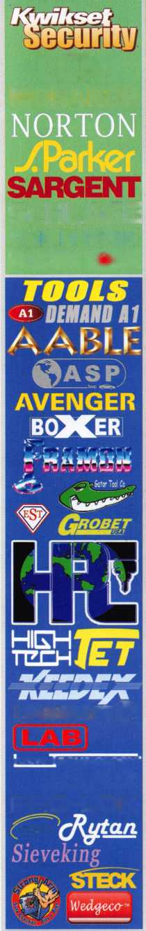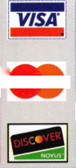

features

AUTOMOTIVE 2005

10

ALOA T-Bird



All the latest info on the grand prize for the ALOA 2006 Convention and Security Expo. Also hear about the exten­sive trek the car has taken as well as where you can get your glimpse.

Concealed Overhead Door Closer Conversion

A national service provider required Eric Costleys services to repair or replace a door closer on the front door of a store, and of course, it was deemed an emergency.

by Eric Costley, CPL



Low Down Jail Lock Blues

Greg Perry ventures north to a small police station to examine and replace a drunk-tank cell door lock.

by Greg Perry, CML, CPS

22



Thomas Jefferson Middle School Wraps Modern Functions in Traditional Architecture

Wrapped in traditional architecture that pays homage to its namesake, the new Thomas Jefferson Middle Schools unique design incorporates a host of features crafted to protect students, teachers, and equipment while providing convenience and functionality to its users.

by Ray I. Scroggins, APR

Products, Service, Marketing

After investing research time and money to buy new equip­ment and/or products for your business, do you believe that is ALL you need to do to take additional revenues to the bank? It may be time to analyze your advertising and pro­motion plans and update your marketing strategy.

by Claire Cohen

The Doctor Is In

Daniel M. Graffeo, PhD is a practicing clinical psychologist who began his medical career as an anesthetist. This would represent a full and satisfying career for most humans, but not for Dr. Graffeo. Most of us know him as a living encyclopedia of vault door and safe lock information, and primarily as THE authority on time locks and movements.

by Brian Costley, CML, CMST

|  |  |
| --- | --- |
| r | 1 |
| AD INDEX | |
| Allstate | Inside Front Cover |
| Gradient Lens | 1 |
| HL Flake | 3 |
| Mil-Comm | 41 |
| Dugmore and Duncan | 19 |
| IR | 33 |
| CCL | 35 |
| American Lock | 37 |
| Turn 10 | 42 |
| PBP | 42 |
| Keedex | 42 |
| Payment Retriever | 42 |
| A&B Safe | 42 |
| Hinge Doctor | 40 |
| Ultralift | 43 |
| KABA llco | 44 |
| Compx | Inside Back Cover |
| Hickok | Back Cover |
| L | J |

**Departments**

Presidential Viewpoint 2

Executi

Appli

cai

ive....

nts

.5 Calendar 8

.6 Core 9

Classified 36 Legislative 40

Associate Members 38

Visit our

NEW website at [www.aloa.org](http://www.aloa.org)

executive

Volume 52, Issue 11



Additional contact information for the ALOA Board and most Keynotes authors is  
available through "Locksmith Search'" on the ALOA Web site- vAvw.aloa.org or by  
contacting the ALOA office at 3500 Easy Street; Dallas, TX 75247; (800)532-2562; FAX  
(214)819-9736; e-mail [aloa@aloa.org](mailto:aloa@aloa.org).

Editor

Betty Henderson [betty@aloa.org](mailto:betty@aloa.org)

Advertising Sales

Kim Hammond voice: 817-645-6778

Fax: 817-645-7599 e-mail: [adsales@aloa.org](mailto:adsales@aloa.org)

Executive Director

Charles W. Gibson, Jr., CAE [charlie@aloa.org](mailto:charlie@aloa.org)

Associate Executive Director

David Lowell, CML, CMST [david@aloa.org](mailto:david@aloa.org)

Convention & Meetings Manager

Jo Anne Mims [joanne@aloa.org](mailto:joanne@aloa.org)

Operations/Membership Manager

Mary May [mary@aloa.org](mailto:mary@aloa.org)

Director of Creative Services

Betty Henderson [betty@aloa.org](mailto:betty@aloa.org)

IT Operations Manager

Greg Jackson [greg@aloa.org](mailto:greg@aloa.org)

Comptroller Kathy J. Romo

Membership Coordinator Shelly Jett

Convention & Meetings Assistant Karen Lyons  
PRP/Education Coordinator Hope Rodriguez

Mail Room Coordinator Kevin Wesley

Creative Media Specialist Margarita Garza

Accounting Coordinator Joyce Nixon

Executive Assistant Sue Langford

Assistant Education Manager Bob Stafford

Legislation Manager Tim McMullen

Contributors

Jerome Andrews, CML  
Paul Chandler, CRL  
Claire Cohen, CML  
Brian Costley, CML, CMST  
Eric Costley, CRL

Ray D'Adamo, CML Billy Edwards, CML Dan Graffeo, CRL,CMST Jim Hancock, CPL Jeff Nunberg, CML, CMST

Randy Simpson, CML, CPP Robert Stafford, CML Dave Thielen, CML Greg Perry, CML,CPS

Tom Seroogy

Charles Stephenson, CPS

Dennis Watanabe, CML, CMST

Mission Statement: The Associated Locksmiths of America, Inc. is dedicated to enhancing the professionalism, education and ethics among locksmiths and those in related sectors of the physical security industry. With approximately 10,000 members in the United States, Canada and the freeworld, ALOA is poised to help members obtain the knowledge, the strength, and the confidence to perform their role in the physical security field with pride and dignity. But it is only through active involvement and participation that ALOA can fully achieve its potential—and can help members to achieve theirs.

Policies: Keynotes® is the official publication of the Associated Locksmiths of America, Inc. (ALOA). Keynotes® acts as a moderator without approving, disapproving, or guaranteeing the validity or accuracy of any data, claim, or opinion appearing under a byline or obtained or quoted from an acknowl­edged source. The opinions expressed by the authors do not necessarily reflect the official views of ALOA. Also, appearance of advertisements and new products or service information does not constitute an endorsement of products or services featured by the Association. The Association does not accept responsibility for the inaccuracy of any data, claim, or opinion appearing in this publication, due to typographical errors on the part of the authors, Association staff or its agents.

Editor's Note: This publication is designed to provide accurate and authoritative information in regard to the subject matter covered. It is provided and disseminated with the understanding that the publisher is not engaged in rendering legal or other professional services. If legal advice and other expert assistance is required, the services of a competent professional should be sought.

Authors' Payment: Payment for eligible submissions to Keynotes will be based on the following criteria: topic, time spent and past contributions. Authors who regularly submit to Keynotes® are generally paid a higher rate. The latter is especially true of authors who write to fit specific editorial needs and submit said copy by Keynotes® deadlines. As a general guideline: Average payment for a 750 word, business or light' technical article would be $200. Payment for a 1500 word article involving significantly higher time and research efforts would be $400.

Payment will not be offered for articles submitted by ALOA employees or members of the ALOA Board of Directors (unless material is of a technical nature), nor for articles submitted by a company that promote that company's products or services. ALOA reserves the right not to pay for articles sub­mitted by an individual(s) that promote a particular company's products or services.

Disclaimer: The Associated Locksmiths of America, Inc., (ALOA), reserves the right to refuse any article for any reason. Additionally, ALOA reserves the right to edit, amend or modify any article submitted for publication in order to preserve technical accuracy, clarity, fairness or grammatical cor­rectness. ALOA will make the best efforts to notify the author of any changes. The extent of ALOA's liability for any article or information contained therein will be a notice of correction or retraction in the next possible issue.

Keynotes® (ISSN 0277 0792) is published monthly except for the combined June/July issue by The Associated Locksmiths of America, Inc., 3500 Easy St., Dallas, TX 75247-6416. Telephone: (214) 819-9733; FAX (214) 819-9736; e-mail [aloa@aloa.org](mailto:aloa@aloa.org). Subscription rates for members—$ 15.00 per year. Periodical class postage paid at Dallas, Texas. POSTMASTER: Send address changes to: Keynotes, 3500 Easy St., Dallas, TX 75247-6416. © Copyright 2003, All rights reserved. No part of the contents may be reproduced or reprinted in any form without prior written permission of the publisher.

President

Robert Mock

(856) 863-0710 president@aloa .org

Secretary

John Soderland, CML, CMST  
(414) 327-5625

secretary@aloa .org

Directors, Northeast

Peter Sarailian, CRL  
(201) 944-7547  
[nedirector@doa.org](mailto:nedirector@doa.org)

Vernon Kelley, CPL  
(609) 771-3126  
[nedirector@aloa.org](mailto:nedirector@aloa.org)

Directors, Southeast

Tom Gillingham, Jr., CML, CPS  
(615) 264-0747  
[sedirector@aloa.org](mailto:sedirector@aloa.org)

Ken Kupferman, CML  
(813)961-5784  
[sedirector@aioa.org](mailto:sedirector@aioa.org)

Director, North Central

William Smith, RL  
(920) 893-5282

Guy Spinello, RL  
(815)394-1000  
[ncdirector@aloa.org](mailto:ncdirector@aloa.org)

Director, South Central

CD Lipscomb, CML, CPS  
(903) 874-3522  
scd i rector@a loa. org

Directors, Southwest

Gordon R. Racine, CML  
(719) 384-4707  
[swdirector@aloa.org](mailto:swdirector@aloa.org)

Julie McCluney, CRL  
(714) 636-5652  
s wd ir ector@a loa. org

Director, Northwest

Jim Jeffries, CPS  
(877) 241-6978  
[nwdirector@aloa.org](mailto:nwdirector@aloa.org)

Director, European

Hans Mejlshede, CML  
(453) 539-3939  
[eurdirector@aloa.org](mailto:eurdirector@aloa.org)

Director, Asian

JoeJ. Lee, CRL ; (215)289-2404

[asiandirector@aloa.org](mailto:asiandirector@aloa.org)

Director, Associate

Paul M. Justen  
(612) 238-4646  
[asdirector@doa.org](mailto:asdirector@doa.org)

Trustees

[trustees@aloa.org](mailto:trustees@aloa.org)

Randy Simpson, CML  
(281) 240-5959

johnj. Greenan, CML, CPS

(773) 486.2030

William Young, CML, CPS  
(610) 647-5042

Past Presidents

2003-2005 William Young, CML, CPS  
2001-2003 Randy Simpson, CML  
1999-2001 John Greenan, CML, CPS  
1997-1999 Dallas C. Brooks  
1995-1997 David Lowell, CML, CMST  
1993-1995 Breck Camp, CML  
1991-1993 Henry Printz, CML  
1989-1991 Evelyn Wersonick, CML, CPS  
1987-1989 Leonard Passarello, CPL  
1985-1987 Joe Jackman, CML  
1983-1985 Stanley Haney CPL  
1981-1983 Louis LaGreco, CPL  
1979-1981 John Kerr, RL  
1977-1979 Clifford Cox, CML  
1974-1977 Charles Hetherington  
1972-1974 Gene Laughridge  
1970-1972 William Dutcher, RL  
1968-1970 Constant Maffey, RL  
1966-1968 Harold Edelstein, RL  
1964-1966 William Meacham  
1962-1964 Robert Rackliffe, CPL  
1960-1962 Edwin Toepfer, RL  
1956-1960 Ernest Johannesen



Keynotes • November 2005

San Francisco

Jonas A. Fernandez

San Jose

Barrett Brockhage

Sponsor: Pablo M. Mediavilla

CT

Marion

Wesley Wade

Sponsor: Gilbert N. Wade CRL Ridgefield

Bryan Gregg

Sponsor: Ernest Lay CPL

FL

Bradenton

David E. Clark II

Sponsor: John T. Hubbard CML

GA

McDonough

Kenneth Deyton

Stockbridge

Stephen A. Hardy CRL

Sponsor: Harold L Hardy CRL

MA

Beverly

Bryan A. Fay

MD

College Park

Robert D. Haught

Oxon Hill

Ayinde Wanzer

Ml

Detroit

Leonard Schmitt

Sponsor: Michael C. Neill CRL

Cary D. Roberson

NC

Charlotte

Marc A. Smith Steven B. Engen

NM

Albuquerque

Michael J. Morrow

Sponsor: James L Hancock CPL Artesia

Cary D. Roberson

OH

Cardington

John C. Hazen

Sponsor: William T. Beranek

OR

Klamath Falls

Gregory J. Cheyne

PA

Concordville

Matthew J. Finn

Sponsor: Michelle Glynn

sc

Florence

Jason L. Young

Simpsonville

Robert O. Yeargin

Sponsor: James L Hancock CPL

TN

Lexington

Gary Hendrix

TX

Austin

Clide R. Nichols

Houston

Gonzalo R. Alvarez

McKinney

Terry G. Alexander

Sponsor: James L Hancock CPL

UT

Payson

James A. Elurkey

WA

Blaine

Todd A. Ives

Sponsor: James L Hancock CPL Bremerton

Jason K. Williams

Kirkland

Greg Hamilton

Sponsor: Robert W. Duman Sr, CML

Wl

Menomonee Falls

Warren Sirnonsen

Sponsor: Mark B. Whitlow CRL Watertown

Donald M. Bean

Sponsor: William J. Smith RL

Santo Domingo Carlos Jaquez

England

RCT Wales

James P. Yeomans

Sponsor: Ken Dale

Japan

Toyota-City Aichi

Tsutomu Takagi

These applicants are scheduled for clearance as members of ALOA. The names are published for member review and comment within 30 days of this Keynotes issue date, respectively, to ensure  
applicants meet standards of ALOA's Code of Ethics. Protests, if any, should be addressed to the Membership Department and must be signed. Active Membership applicants (a) have worked in  
the industry two or more years. Allied Membership (AL) applicants are not locksmiths, but work in a security-related field. Apprentice Membership (AP) applicants have worked in the industry less than two years.



Keynotes • November 2005



**R I AC HING NEW Hit G H TS**

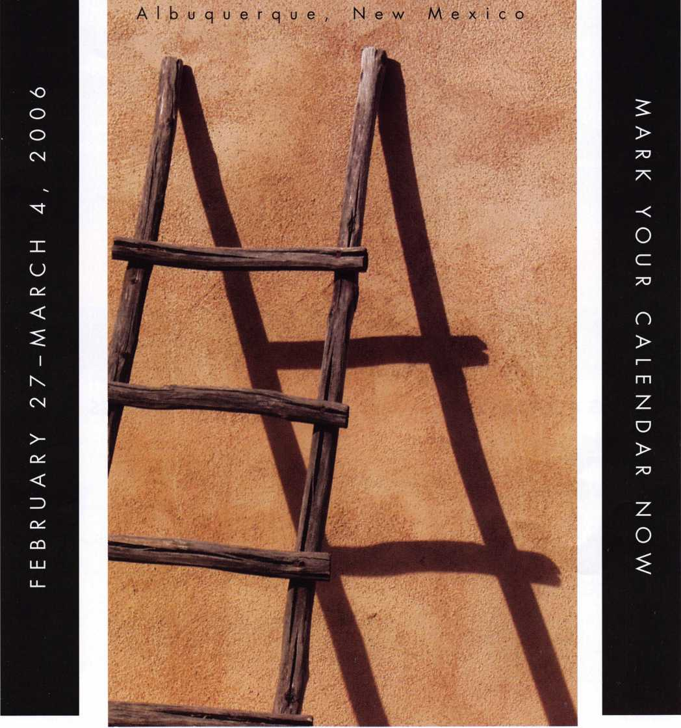

When it comes to learning about the  
latest in safes and vaults, time is of the  
essence. SAFETECH 2006 features an  
all-new menu of classes, covering every  
safe topic on the globe. Don't miss out!



**JAN | DEC I NOVEMBER**

upcoming events

|  |  |
| --- | --- |
| 2-5 Yankee Security Convention  ACE Classes, Trade Show & PRP Sturbridge, MA | 3-5 California Locksmith Assn. Convention 4 Greater Houston Locksmiths Assn 5 Greater Houston Locksmiths Assn  Burbank, CA Automotive tips & tricks / All day auto hands-on class  open forum For registration info contact: Judy  For registration info contact: Judy Clifford, phone 979-297-2413  Clifford, phone 979-297-2413 |
| 9 NYAIL General Meeting  6:00 pm  New York, NY | 14-18 DHI Technical School 16 NJMLA Monthly Meeting. 18 ALOA Open House  Orlando, FL Third Wednesday of every month. 3500 Easy Street  Call (201)944-7547 or Dallas, Texas 75247  (201)947-6291 for time 10a.m.-4p.m.  and location. |

18-19 ALOA Fall Board Meeting Radisson Hotel 2320 W. Northwest Hwy. Dallas, Texas 75220

5-10 Dallas, Texas  
Six-Day Basic  
Locksmithing Course

Contact: Hope Rodriguez

Phone: 800-532-2562x104

Oklahoma Fire & Burglar Alarm 21 State Advisory Committee Meeting 10:30 am

Oklahoma City, OK

NJMLA Monthly Meeting.

Third Wednesday of every month. Call (201)944-7547 or (201)947-6291 for time and location.

|  |  |
| --- | --- |
|  |  |
| 10-12 Minnesota Chapter Associated I Education Weekend Reservations, 651-770-2811 Maplewood, MN | .ocksmiths of America |

UPCOMING ACE CLASSES

**UPCOMING PRP SITTINGS**

11 /2-5/2005 Sturbridge, MA • Yankee Security Convention (9 classes)

Jack Hobin, CPL, • [info@yankeesecurity.org](mailto:info@yankeesecurity.org)  
800-209-8266

1 1/12/2005 Detroit, Michigan • Locksmith Security Association • Robert C.

Nobel, CML 810-385-9329 Large Format 1C w/L-39 PRP

1 1/19-20/2005 St Louis, Missouri • BiState Chapter of ALOA •

Basic Auto Transponders Systems

Advance Transponders Systems & Keyless Remotes

Robert Theobold 314-340-6804

12/5-10/2005 Dallas, Texas • ALOA ACE Program  
Hope Rodriguez 800-532-2562 xl04  
6 day basic locksmithing course

11/5/2005

11/10/2005

11/12/2005

11/13/2005

11/19/2005

12/08/2005

Saturday 9:00 am • Sturbridge, MA • Yankee Security Convention Jack Hobin, CPL • 800-209-8266

Thursday 9:00 am • Dallas, TX • ALOA Hope Rodriguez 800-532-2562

Saturday 8:00 am • Cary, NC • North Carolina Locksmiths Association Granger L. Marley, CML 919-859-6060

Sunday 8:00 am • Baltimore, MD • Clark Security Products Joan Emrick 619-718-7308

Saturday 6:00 pm • Bi-State Chapter of ALOA •

Kenneth Kim, CRL, CPS 314-351-7252

Thursday 9:00 am • Dallas, TX • ALOA Hope Rodriguez 800-532-2562



**\* core**

ALOA Open House

Be the first on your block to get an inside view of ALOA's new headquarters office. Join us for an open house November 18, 2005, 10 a.m.-4 p.m.. Call (800)532- 2562 for more details.

Locksmith • Musician • Friend 1947-2005

Jim Langston was much more than one can convey in mere words. Jim passed away at roughly 3:30 a.m. on September 25, 2005 at a hospital in Fort Worth, Texas. The exact cause of death is not yet known but could be related to a head injury sustained in a bathroom fall at the hospital. Jim was in the hospital for surgery to relieve a serious infection in his foot. His longtime friend and musical partner, Francis Freeman, was at his side when he died.

Jim is survived by his wife, Sharon, his son and daughter of Fort Worth, Texas, his father and step-mother of Sherman, Texas, his mother and sister of Fort Worth, Texas, and many friends including ALOA Board Member, C.D. Lipscomb, CML, CPS.

C.D. Lipscomb stated, "Whatever the organic cause of his death, I will always believe that the real reason he died was from a broken heart. Due to health problems, Jim had been separated from the locksmtihing industry that he had be a part of for so long. He began lock- smithing in the 1960s as an apprentice, working throughout his life at shops in Arlington, Tyler, Houston, and Fort Worth, Texas. His health problems seriously curtailed his other interest in life, which was playing music. I think that Jim was mostly a musician at heart. Weekly, he played fiddle and mandolin in a sidewalk musical group. In past years, he had worked as part of the road entourage for several Country c nd Western groups."

Jim's illness caused him to be down and sometimes cross but over all, loved ones remember Jim as one of the most upbeat and positive people they knew. Jim always had a joke to tell. Usually, it was corny and he told the same one all day, but he had thousands of them. C.D. remem­bers, "Even though at times he was confined to a wheel­chair, other times he was blind, and sometimes alone, I only heard him sound really down once when he was forced to go on kidney dialysis. The next day, however, he was bouncing up and down proclaiming that it was the best thing since ice cream. He was genuinely the most positive person I ever knew."

Jim worked in the Texas Locksmith Association for many years. He first served as a Board Member in the 1980s. In the 1990s, he served as Editor. He consistently impressed others with his concern and devotion to other locksmiths. He stood for quality education and training at an affordable level. He attended many association meet­ings and served as an Associate Instructor with his friend, C.D. Lipscomb all over Texas and Oklahoma.

C.D. recalls the energy his friend brought to their road trips together, "There was no going to sleep while driv­ing with Jim. He would tell stories nonstop from start to finish of any trip." Jim fondly remembered a trip to the ALOA Convention and Security Expo in Nashville, TN. It was 1998 and Jim was able to visit both his locksmith friends and old friends from the music business. The last trip C.D. Lipscomb and Jim Langston took together was to The Texas Locksmith Association Convention in Corpus Christi, Texas in March of 2005.

"One does not pick their friends. They just happen. I am just fortunate that Jim's friendship happened to me. I will miss him very much and I know that each of his friends will have more and even better stories to tell about Jim than I do. I hope they will share them with me.", said C.D. Lipscomb.



Keynotes • November 2005

Are We There Yet?

The ALOA 1956 Ford Thunderbird Takes Off for it’s Final Destination... You!

**IAS VEGAS**

Excitement has been building for  
the 2006 ALOA Convention and  
Security Expo as this year marks the  
50th anniversary of the show  
(1956-2006). ALOA is celebrating  
by giving member attendees a  
chance to WIN an amazing  
1956 Ford Thunderbird.

Sponsored by Compx, FKI Security  
Group and IR Security and Safety,  
the ALOA T-Bird has crossed the

visiting locksmith shops and security shows.

Being pulled in a trailor by the ALOA Training Center van, the T-Bird has met hundreds of members and seen countless landmarks along the way. From rainstorms in Minneapolis to Hurricanes in Florida, every moment has been an exciting part of this wonderful journey.

Hundreds of members have made their way to national events to get a glimpse of the T-Bird and throusands more are tracking it’s progress online at [www.aloa.org](http://www.aloa.org).

The best part of the trip, however, will be awarding this car as a door prize to one lucky ALOA member who is present at the 2006 ALOA Convention and Security Expo in beautiful Las Vegas, Nevada.

History

The Ford Thunderbird is a car manufactured in the USA by the Ford Motor Company. It entered production for the 1955 model year as a two-seater sporty car; unlike the super­ficially similar (and slightly earlier) Chevrolet Corvette, the Thunderbird was never sold as a full-blown sports car.

When introduced to the motoring public, the two-seat 1955 Thunderbird was an immediate sales success. The only nega­tives that Ford heard: blind spots when the hard top was in place and not enough room in the trunk to hold two sets of golf clubs .

Those consumer woes were quickly addressed with the 1956 Thunderbird featuring a hard top with a round porthole on each side. To make space in the trunk, the 6.70x15-inch spare tire was hung off the rear of the car. The dual exhaust pipes were redirected from exiting through the trunk and

out the valance above the rear bumper to exiting through slots at the corners of the rear bumper, avoiding the trunk altogether.

Only 15,631 Thunderbirds were built in 1956. Each one weighed 3,038 pounds and carried a base price of $3,151. Ford described it as a personal luxury car, a description which named a new market segment.

Genesis

Three men are generally credited with creating the original Thunderbird: Lewis D. Crusoe, a millionaire lured out of retirement by Henry Ford II to improve the Ford range; George Walker, chief stylist and a Ford vice-president; and Frank Hershey, a Ford designer. Crusoe and Walker met in France in October 1951. Walking in the Grand Palais in Paris, Crusoe pointed at a sports car and asked Walker, 'Why can’t we have something like that?'

Walker promptly telephoned Ford's HQ in Dearborn and told designer Frank Hershey about the idea. Hershey took the idea and began working on the vehicle. The concept was for a two-passenger open car, with a target weight of 2525 lb (1145 kg), an Interceptor V8 engine and a top speed of over 100 mph (160 km/h). Crusoe saw a painted clay model on May 18, 1953, which corresponded closely to the final car; he green-lighted the car in September after compar­ing it with current European trends.

Unlike the Corvette, the Thunderbird was never a full-blown sporting vehicle; Ford's description was personal luxury car, and the company essentially created this market segment.

Naming

There was some difficulty in naming the car, with sugges­tions ranging from the exotic to the ridiculous (Hep Cat, Beaver, Detroiter, Runabout, Arcturus, Savile, El Tigre, and Coronado were submitted among the 5,000 suggestions). One serious suggestion was Whizzer. Crusoe offered a $250 suit to anyone who could come up with a better name.

Stylist Alden "Gib" Giberson submitted Thunderbird as part of a list. Giberson never claimed his prize, settling for a $95 suit and an extra pair of trousers from Saks Fifth Avenue.

**10**

Keynotes • November 2005



St. LoUh

Bahama

See

More

Pictures

Online!

The car was shown at the first postwar Detroit Auto Show on February 20, 1954. The first production car came off the line on September 9, 1954. It went on sale on October 22, 1954) as a 1955 model, and sold briskly; 3,500 orders were placed in the first ten days of sale. Ford had only projected building 10,000; eventual 1955 sales were 16,155.

As standard, the 1955 Thunderbird included a removable fiberglass top; a fabric convertible top was an option, although commonly specified. The only engine option was a 292 Y-block V8. The exhausts exited through twin "bullets" above the rear bumper, as was the fashion.

For the 1956 model, Ford made some changes. To give more trunk space, the spare wheel was mounted outside, Continental-style; the exhausts were moved to the ends of the bumper. Air vents were added behind the front wheels to improve cabin ventilation. To improve rear-quarter visibility with the removable hardtop in place, "porthole" windows were added to it. An optional 312 Y-block V8 was made available for those that wanted more performance.

1956 sales were 15,631 units, the lowest of all three 2-seater Thunderbird model years.

For 1957, a more radical restyle was performed. The front bumper was reshaped, with heavier sides, "bullets" at the ends of the grille, and the section below the grille dropping down. The grille was larger. The tailfins were made larger, more pointed, and canted outward; larger round tail-lights were fitted. The spare wheel moved inside the trunk again, which had been redesigned to allow it to be mounted verti­cally and take up less space. The side "Thunderbird" script moved from the fins to the front fenders.

Engine options increased, because Ford went racing with the Thunderbird that year. As well as the standard 292 and 312 engines, versions of the 312 were produced in higher states of tune, and even a McCulloch supercharged version.

Don’t miss your chance to take this car home from Vegas July 13-15, 2006! Sign up today to attend ALOA 2006 and your name will be placed in the Sunday after­noon drawing. For more information on attending and/or joining the ALOA membership, please call

According to Palm Springs Life magazine, the car's final name came not from the Native American symbol as one might expect, but from an ultra-exclusive housing tract in what would later be incorporated as Rancho Mirage, California: Thunderbird Fieights.

1955-1957 "Classic Birds"

1-800-532-2562x218.



Keynotes • November 2005

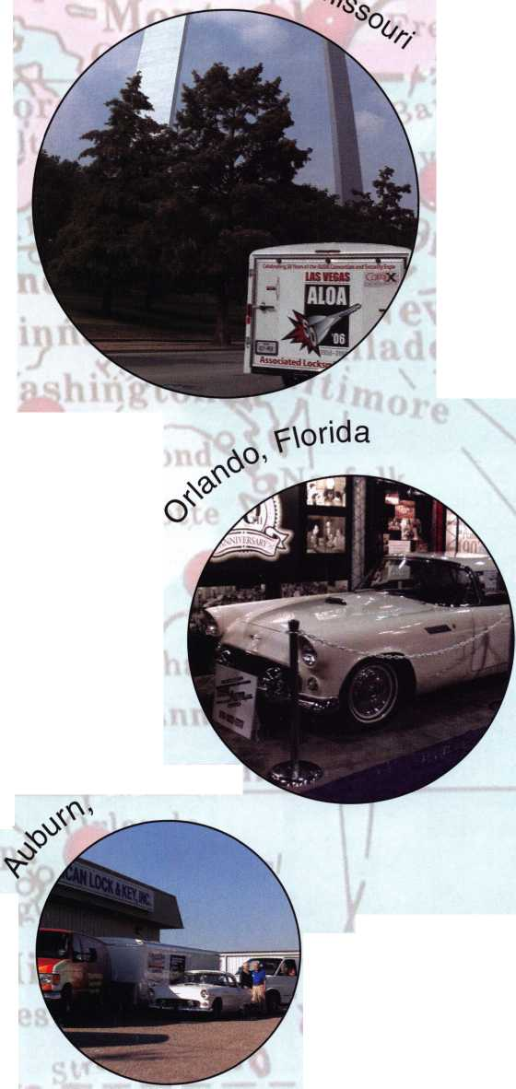

**CoNCEAtE ^Overhead**

**Conversion**

r

By Eric Costley, CPL

1



We frequently get calls and work orders faxed from national service providers who require work in our area. Among these are Security Solutions, National Glass & Gate, Cornell Storefront Systems, Locksmith USA, Metro Door, Nationwide Security, and many others. One of the "fun" things about doing work for any national service provider is

headquarters, who contacts the national service provider.

The service then contacts us with a request for "emergency service", normally with a "same day" or "24 hour" stipula­tion, and usually with a "DNE" (or do not exceed) amount. The fax usually arrives about 4 p.m. That leaves us less than an hour to arrive, figure out what is actually needed, and fin­ish the task. We have learned, over time, to approach things a little differently.

Once the fax arrives, we call the local store in an attempt to find out exactly what is required and how urgent the call actually is. Often we find out that the problem has been going on for months and it is not actually an emergency.

At this point, we simply schedule a convenient time and then do the work. Not everything goes this smoothly, but we have found that more often than not, emergencies are rare.

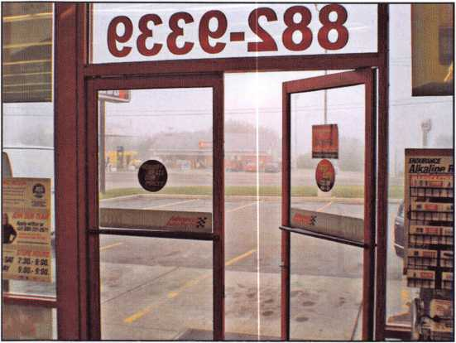

Here's the door, swinging in thebreeze before we began.

deciphering what the customer actually needs. Here's how things typically go.

The store manager at a local store calls their district rep about a problem. The district rep, in turn, calls corporate

All this background brings us to the job in question. A national service provider required our services to repair or replace a door closer on the front door of a store. This of course, was deemed an emergency. After calling the store, we found out that the door would close and lock, but that the closer was not functioning properly and the door would stay open unless you closed it. I asked if the door closer was leak­ing fluid and was assured that it was not. We scheduled the job for the next morning.

**2**

Keynotes • November 2005



When I arrived on the scene, I was surprised to find that these were center-hung doors with overhead concealed door closers. (These allow the doors to swing in either direction.) I knew enough to loosen the overhead cover to reveal the closer so that I could identify it, but that was pretty much all I could do at the time. (Overhead closers are not something that we service much, or anything that I have had much experience with.) I explained to the cus­tomer that yes, the closer was shot, and I would have to order one.

That's where the fun began!

Some national service providers like to ship out their own replacement parts. Some will have you order them from your regular supplier. Some ship directly to the end user, others ship to you. Trying to keep track of "who does what" is virtually futile. Even those that like to ship out their own parts will occasionally ask if you can provide the needed materials, depending on what is required. In any case, we called the national service provider to explain that a new Jackson overhead concealed closer was required. A day or so later, they called back.

Evidently, the corporate headquarters of this chain had decided that they would like the doors converted so that they would only swing out, with door stops and surface mounted closers installed. Of course, since the concealed closer also acts as the top pivot for the doors, it would be necessary to install continuous hinges as well. We did the required math, and faxed over a quote. Two days later, we got yet another phone call. The quote had been accepted, but corporate wanted all exposed materials painted a spe­cific color to match the doors. (Sometimes it's difficult not to snicker on the phone.)

A day or so later, we called back and explained that other stores in the area had these parts installed in a satin chrome finish and that was all we could supply. After yet a couple more days, we received the go ahead and ordered the required parts.

At this point, I have to give credit to Hank Fuller, CPL, who had a brilliant idea. (Hank is one of my esteemed employers at Bill's Locksmithing.) If we were to convert the doors in question from center-hung to doors with exterior continuous hinges, it would mean moving the doors further out toward the exterior of the frame, which would mean re-

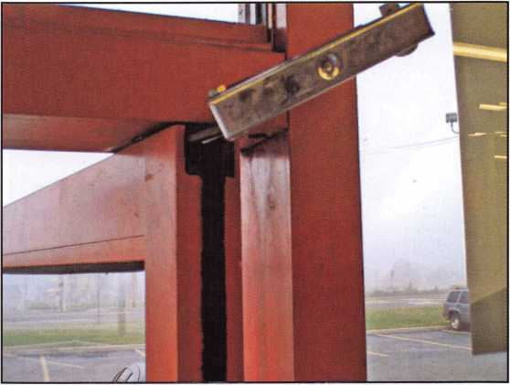

Two hex head bolts secure the door to the overhead closer. Once these are  
removed, the doorslips off the bottom pivot and can be dropped.

drilling for the flush bolts of the stationary door, as well as having to re-align the active door to lock into the stationary door. Although this doesn't sound like a great deal of work, once you get into a project like this, you would find that these "minimal" adjustments take a great deal of time and finesse to accomplish successfully. Hank remembered using

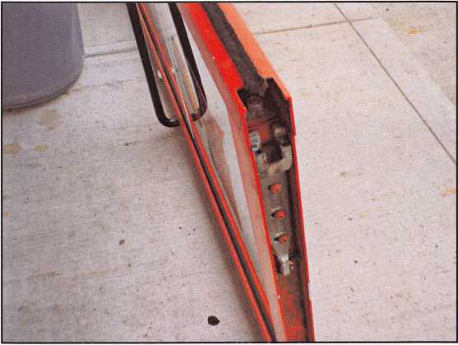

Once the door is down, we can see the arm for the concealed closer, as well as how  
it attaches to the pivot of the concealed closer.

"dummy" concealed closers on a job, and sure enough, Jackson manufactures such a beast.

So, what is the advantage? The dummy closers fit the same footprint of an active concealed closer, acting as a pivot, but without the closer function.

This means that the doors need not be re-aligned, which means less time, labor, and cost!

Keynotes • November 2005

**13**

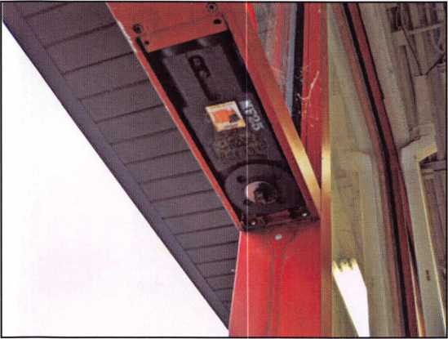

There are 4 bolts that secure the overhead closer to the frame, and two of them  
secure the cover. Once the remaining two are removed, the closer slides to  
one side and can be removed.

Dropping the doors is necessary to replace any overhead concealed closer. In most cases, dropping the doors simply requires removing two hex head bolts which secure the door to the pivot of the overhead closer. Taking down a fullsized aluminum frame door with an insulated glass unit can be a daunting task, but even with my slim 155 lb. build, I can accomplish it by myself with a great deal of care. We had agreed to meet at the store at 8:30 am to start the job and by the time Hank had arrived, I had the first door down, and was starting on the overhead closer.

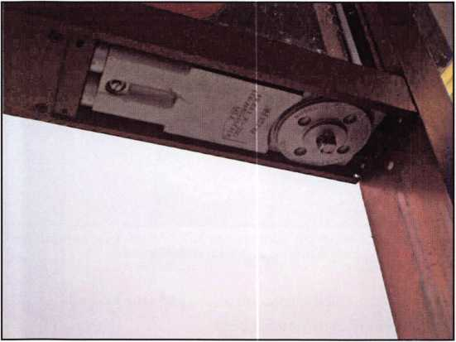

The "dummy closer" looks just like the active one!

While I was replacing the closer with the dummy and dodg­ing customers in an attempt to re-hang the door, Hank was installing the surface-mounted door closer on the other door.

When each of us was through with our respective task, we switched doors, and went back to work.

Once the dummy closersand the new surface mounted closers were installed, all that remained was to create a sill to prevent the doors from swinging inward. Using the flush bolts of the stationary door to lock it in place and then securing the active door with the Adams Rite deadbolt, we simply attached a strip of aluminum across the top of the frame. We checked the alignment a time or two, and then headed for the counter for the required "store stamp and sig­nature".

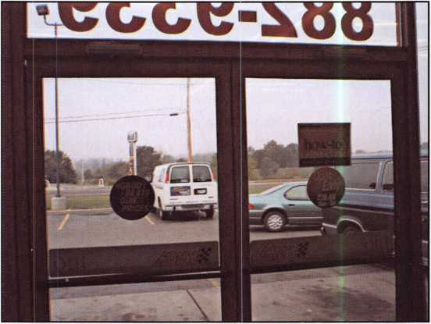

Once the new closers had been installed, all that remained was to create a "stop" to  
prevent the doors from being forced inward.

From the time of the initial request for service until the com­pletion of the job, it was approximately 6 weeks. (So much for an "emergency" call!) However, it is important to note that if you work with these national service providers on a regular basis, they tend to flex a bit if they know that you are reliable and can do the requested work. In addition, I need to mention that Hank and I had this job done in less than 1 hour! (I had expected 3 or perhaps 4.) Because of Hank's knowledge of the Jackson dummy closers, we saved ourselves a ton of work. This only goes to show that doing your research ahead of time always pays off in the long run.

I was afraid of concealed overhead closers and concealed "in­floor" closers before this. But after my experiences with Bill's Locksmithing, I have learned that there is, (to reiterate a famous quote,) "nothing to fear but fear itself." Overhead closers? Check out Jackson Exit Devices.



Keynotes • November 2005

One of the greatest tools that you can toss into your toolbox is confidence. You might not even realize how much knowl­edge you have compared to the rest of the competition, and utilizing that knowledge can translate to money in your pocket. It is never a shame to go look at a job that you think you might not be able to tackle, and then to pass on it. After all, locksmithing is a never ending learning experience!

If you think you know it all, and don't need to take classes or rub elbows with other locksmiths, you're ready for retire­ment. After 25 years, if I don't learn something new every day, I count the day a loss.

There are a few days that I count as a loss, but very few! As the industry changes and grows, so must we, in order to meet the needs of our customers.

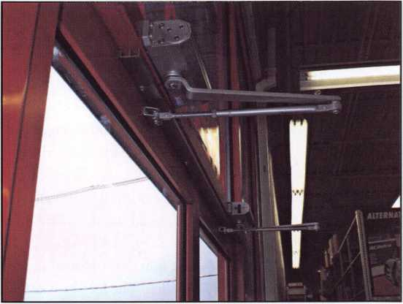

Once the job was complete, all that remained was the obligatory store stamp and  
signature, and the anticipated 90 days before we actually get paid for the job!



Keynotes • November 2005

Low Down Jail Lock Blues

By Greg Perry, CML, CPS

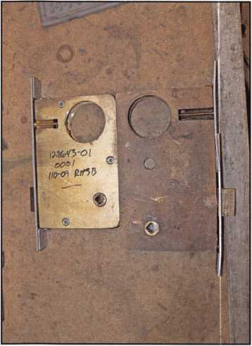

Last December, I ventured north to a small police station to  
look at the drunk-tank cell door lock. The lock was failing  
fast. I attempted a patch until a new lock could be procured.  
I called Folger Adam to find out if a model 125 was still  
available. If not I wondered what I could use to replace it.  
The gentleman in technical support suggested I replace it  
with a model 110. I confirmed the function I needed so I  
could place the order with my supplier. The lock arrived in  
July just before I left for the ALOA convention and Security

Expo Chicago.

They didn't tell  
me the locks were  
not the same size.  
Six months of  
waiting and lock  
wasn't the same  
size? I was 140  
miles from home  
and needed to get  
this job finished.  
The backset is dif-  
ferent. The spin-  
dle hole is in a dif-  
ferent location.  
The lock case is  
smaller and they  
sent the wrong

function. No problem. After all, I've traveled more than 50

Photo 1 shows the two locks next to each other. In this picture you can see how different the locks are in size.

|  |  |  |  |
| --- | --- | --- | --- |
| miles and the local lock- | —i | r | 1 |
| smith had recommended |  |  | ■ |
| me. That makes me the |  |  | pi |
| expert. The customer | 1 | ) | t |
| expected results and |  | J | j i |
| chances were I couldn’t return this $1000.00 mortise lock. It was time to rethink why I take these jobs. (Or at least |  | f | 1 |
| regroup and figure out | The mortise pocket and existing | | |

how I might make this lock holes are seen Photo 2-

work.) (Photo 2) If I tried to back out and re-quote it and the customer don't take it I would be stuck with a lock, plus a wasted day.

Desperation is a great motivator. Starting with the lock case was anything going to work? I wondered if attaching the lock at the upper-mounting tab and moving the backseat

The latch face is being modified for use with the new mounting tab in photo 3.

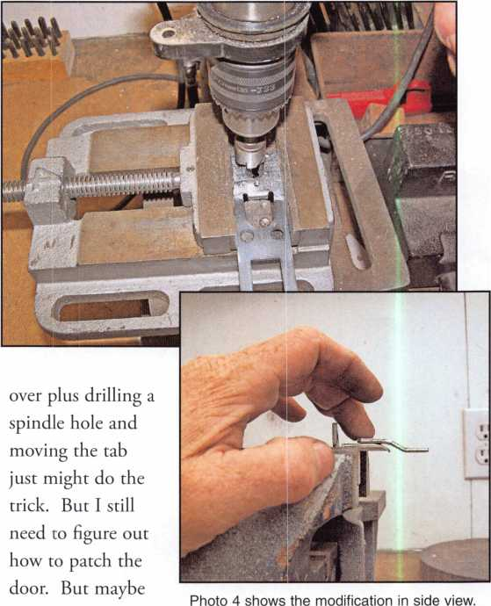

just maybe I could

still make it out of this job with the shirt on my back.

I decided to start with the tab issue. Looking through my truck I found some Major Mfg. LMB tabs for mortise locks. If I re-drilled one just right it might reposition the mounting for the lower lock case screw. (Photo 3 & 4) It worked, one problem solved... on to the next. It worked, one problem solved... on to the next. The original backset was 3” this lock was 2 3/4”, the Folger Adam mortise cylinder uses a 2

**6**

Keynotes • November 2005

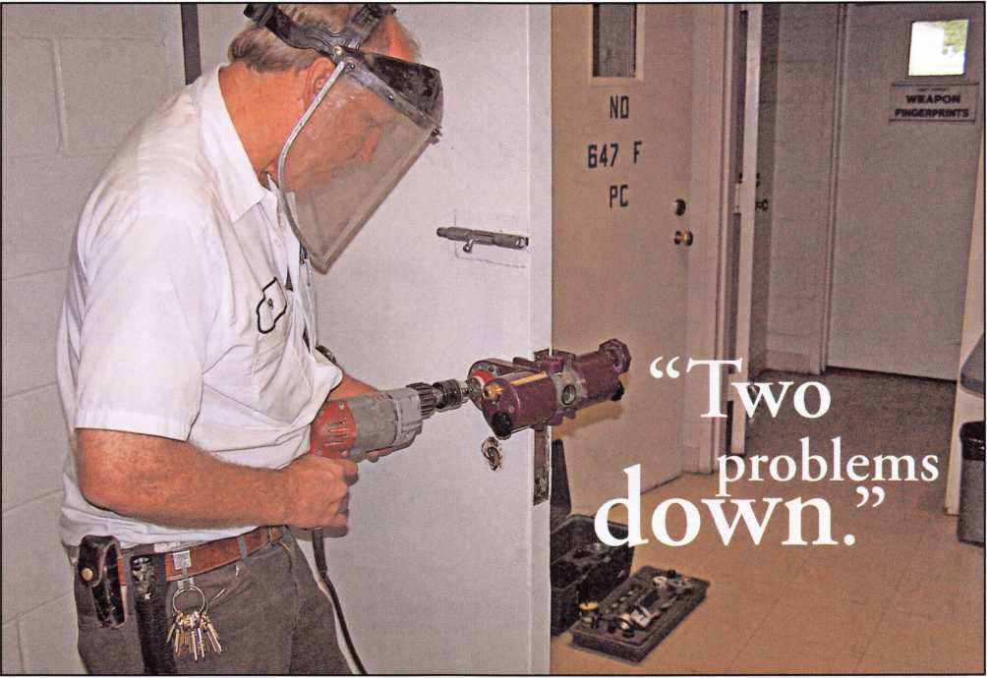

Photo 5 shows me redrilling the cylinder hole using a Major Hit44 drill fixture.

1/8” hole in the door. Not much thought here so I grabbed the lock installation jig and used it as a guide for the hole saw to move the hole over.(Photo 3) Two problems down. Drilling a new spindle hole in the door easily solved problem number three. (Photo 6) Patching the door was next. I went back out to the truck for a push plate. Before installing the plate on the door I drill the spindle cylinder hole using the drill press in the truck. (Photo 7)

Keynotes • November 2005

Solving the problem with the function was a little  
more difficult. I thought I ordered a lock with no  
inside trim and a rigid outside trim. Instead, the  
lock was a storeroom model, rigid outside and  
always free inside. There were two problems here.  
First, the inside of a jail door should not be free  
exit. Second, we wanted no inside trim. This was  
a padded cell. The jailers wanted no place for  
prisoners to hang themselves or beat themselves  
up with. This lock used a typical mortise spindle  
design with inside knob screws onto the spindle  
from the outside knob. Retaining the outside

In photo 6 you can see the lock in the newly drilled holes.

The cylinder is installed through the push plate in photo 7.

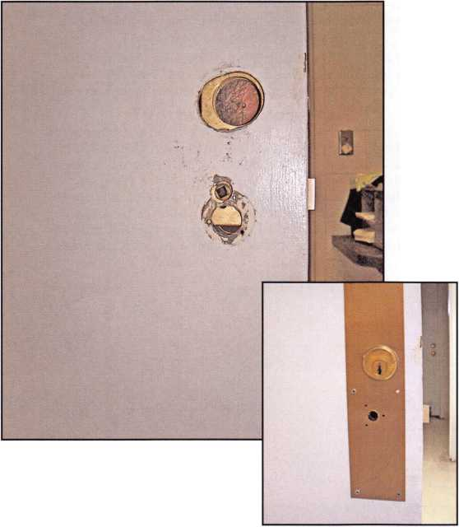

**RING of a KING**

Member Name Sponships

Kwok-kei Leung 220

Henry W. Raymond 91

Yuriko Yanai 82

Mary S. Ohmit CPL 66

Charles C. Robertson CML 65

William Lee CRL 62

Jack Hobin CPL 51

Clifford D. Lipscomb CML, CPS 51

Michael B. Groves 47

C Allan Halverson 40

David M. Troiano 51

Myeong-Rae Cho , 38

Jim Williams CRL 40

David M. Lowell CML, CMST 36

Salvatore J. Dulcamaro CML 36

Dana L. Barnum CML 35

Barry K. Leas CRL 35

Danny W. Rudd CPL 31

Larry A. Warnick CML 31

Eugene R. Altobella Sr 31

Jeanne G. Lodge CML 30

Robert D. DeWeese CML 30

Scott L. Henke CPL, CPS 29

Dallas C. Brooks 28

Breck H. Camp CML 27

Lawrence F. Smith Jr, CML 27

John C. Elliott Jr, CML, CPS 28

Marian M. Swann CRL 27

James M. Watt CML, CPS 26

Robert W. Duman Sr, CML 29

William L. Young CML, CPS 33

Anthony J. Ramunno CML, CPS 24

Jeffrey S. Nunberg CML, CMST 26

J Thomas Hood CML 26

Ken Dale 26

Robert H. Stafford CML 25

Philip A. Rovenolt CPL 25

William T. Beranek 29

John L. Shandy CML 25

Elvis D. Hammerschmidt CPL 25

Jerome L. Cohen CML 22

Peter K. Gauthier CPL, CPS 22

Man-Soo Seo RL 23

James J. Cawby CML, CPS 22

James L. Hancock CPL 27

Hans Mejlshede CML 25

John S. Dorsey CML, CPS 20

Thomas G. Vandersteen CML, CPS .19

Peter Sarailian CRL 23

Walter W. Lascar RL 18

Keizo Takahashi CRL 18

James E. Fowler Sr, CML 18

David C. Harris CML 18

Ronald E. Heidzig 18

Joe J. Lee CRL 18

Takashi Kuwana CRL 19

Eugene R. Altobella Jr 17

Ernest W. Wright 18

Peter R. Hall 17

William P. Grant CRL 20

James E. Gruber CPL 18

Evelyn V. Wersonick CML, CPS 15

Joseph P. Ferrero CML 15

Gary F. Teams CPL 14

Kenneth E. Kim CRL, CPS 16

William J. McElheney CML 18

John W. Soderland CML, CMST 15

Michael E. Jordan Jr, CML 15

Jon B. Griswold CML 16

Brian J. Reetz 15

John A. Ilk CRL, CPS 16

Russell P. Fuller CRL 16

Robert C. Rodocker CPL 13

John J. Greenan CML, CPS 15

Steve L. Cothron 15

Leonard J. Passarello CPL 14

Bruce J. Tarbet CML, CPS 12

John D. Cannon CML 14

Paul M. Souber 14

James T. Brickler CPL 14

Calvin G. Harris CML 13

Frank D. Hartung CML 13

Rolando Bouza 13

John F. Engel CRL 14

Richard C. Sievers 14

Brooke P. Berry CRL 13

William J. Wickward CML 12

Raymond C. Lusk CML 10

Robert M. Massard CRL, AHC 12

Gregory L. Perry CML, CPS 14

Eric F. Veal 12

Barry L. McMenimon CRL 12

Thomas J. Demont CML, AHC 11

Basil W. Shannon CPL 12

Ralph O. Warren CML 10

Gordon R. Racine CML 11

Kevin R. Wilson CML, CPS 11

Timothy K. Chow 10

Dale L. Knowles CPL 11

Timothy J. Moore CRL 13

Andrew A. Edmunds CML, CPS 11

Daniel S. Enriquez CRL 11

Gene Eldridge CPL 10

Ronald P. Riggins CML 11

Charles E. Haas CML 10

Robert E. Mock 12

Lester S. Brodsky 10

Larry L. Votaw CML 10

Thomas R. Smith CPL 10

Todd K. Ladwig CML, CPS 10

William! Straub CML 10

Randy L. Hutchison CRL 10

Richard T. Johnson CPL 10

Vincent L. Formon CML, CPS 10

Carroll T. Croson Jr 10

Marian E. Sagar 10

Andrew S. Dennison CPL, CPS 10

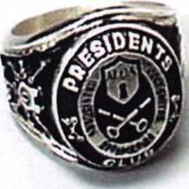

How can I join the President's Club?

You can earn a membership in this prestigious club by recruiting  
just 10 new members for ALOA.

*Any ALOA member may participate.

What do I get?

When you recruit 10 members, you receive a  
handsome blue blazer with a President's Club crest.  
For each additional five members you recruit, you  
receive a lapel pin with gold-filled numbers, indicating,  
your recruiting successes.

You also get the satisifaction of knowing that you are  
helping your association, helping your industry grow,  
and you are helping fellow locksmiths achieve success.

How do I get started?

Mail the form below to the ALOA office for a supply of  
applications (800) 532-ALOA or FAX (214) 819-9736.  
One President's Club credit is awarded for each new  
applicant. Credit is awarded only after the membership  
application is pproved. However, the credit will apply  
for the period in which the application is received.  
Failure to identify yourself as the sponsor on the applica-  
tion form at the time it is submitted to ALOA for process-  
ing will forfeit any credit.

|  |  |  |
| --- | --- | --- |
| Yes!  Please r | | 1 want to join the ALOA President's Club.  ush me applications so 1 can start earning credit toward membership in the club! |
| Name | |  |
| Company | |  |
| Address | |  |
| City | Slate | Zip |

Mail this form to ALOA • 3500 Easy St. • Dallas, Texas 75247-6416

**Hardwiring Made Easy"**

Make the perfect connection every time with SARGENT’S ElectroLynx. The plug-in universal connectors and the easy, color-coded wire system eliminates matching wires. Wiring is a snap and completely fool-proof.

SARGENT

Look for the LYNX

ELECTROi

As part of their promise to provide innovative, fast and effective, and higher security solutions to their customers, ASSA ABLOY Group  
companies offer ElectroLynx, a universal quick-connect system that simplifies the electrification of the door opening.

Dugmore introduces NEW Memphis, TN location.

Dugmore & Duncan is committed to getting our products to our customers ASAP. Our research revealed that Memphis TN has an innovative business plan to make the most of its strategic location and natural resources. It is a multi-carrier transportation hub.

D&D has consolidated a substantial amount of its warehouse inventory into a prime Memphis location. In addition to our current strategic points of distribution, Dugmore delivers from Memphis. We are confident that this is a great opportunity for Dugmore and for our loyal customers.

DUNCAN

**Securing Your World**

*Distributor of*

**SARGENT**

*Products*

**Call (888) 384-6673**

FAX (888) 329-3846 • [www.dugmore.com](http://www.dugmore.com)

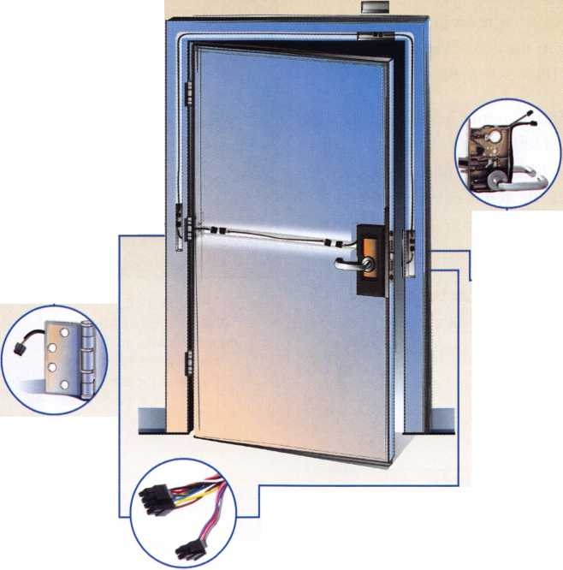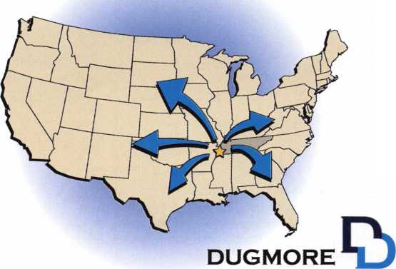

knob to the rosette without an inside knob was not an option. While contemplating how to retain the knob I realized that I didn't need a spindle hole in the door. The outside knob was only a pull. I drilled a hole through the rosette and spindle for a roll pin to hold it place. Next, I used the three screw holes in the rosette to attach the trim assembly to the door. The lock installation was complete. (Photos 8 & 9)

I cleaned up the oversize mortise cutout in the edge of the door with a piece of the old faceplate. I also installed a modified Don-Jo BF178 hole filler in the existing spindle hole. (Photo 10) It was below the level of the old lock case and left a spot for prisoners with nothing better to do totry and scratch their way out.

I left with a reasonably satisfied customer but he sure didn't like my price although I felt I didn't charge enough. The thing we both agreed on was that the installation looked good.

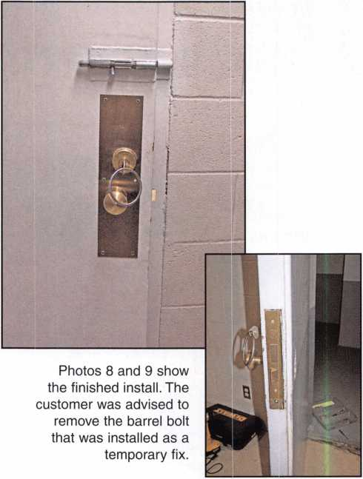

Photo 10 shows the old inside  
spindle hole. The padding on the cell door has been  
scratched away with fingernails over the years. A  
patch made with the DonJo hole filler can be seen  
in the lower left corner of the hole.

**20**

Keynotes • November 2005

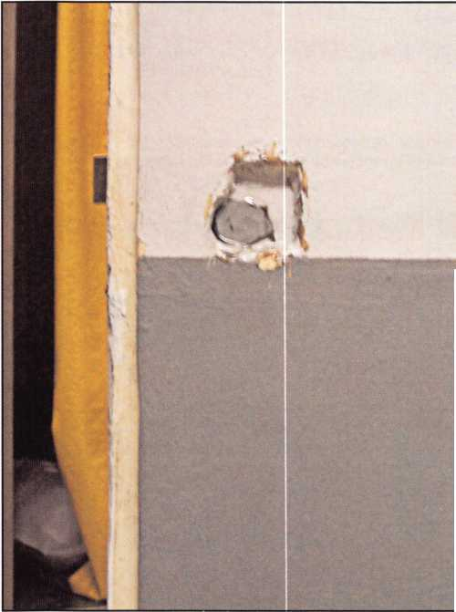

|  |  |
| --- | --- |
| pip I |  |
|  |  |
|  | v 2006 |

fverV

bodV w«nts it-You MIGHT TAKE

IT HOME!

One Lucky Member Attendee at ALOA  
2006 is going home with this gorgeous  
mint-condition 1956 Ford Thunderbird.

A ticket will be given to each ALOA  
Member who registers and attends the  
show. Someone has to win it, and it  
might as well be YOU!

(Must be present to win. Exhibitors,  
Employees. Family Members of Employees, and  
nonmembers **are not** eligible for this door prize.)

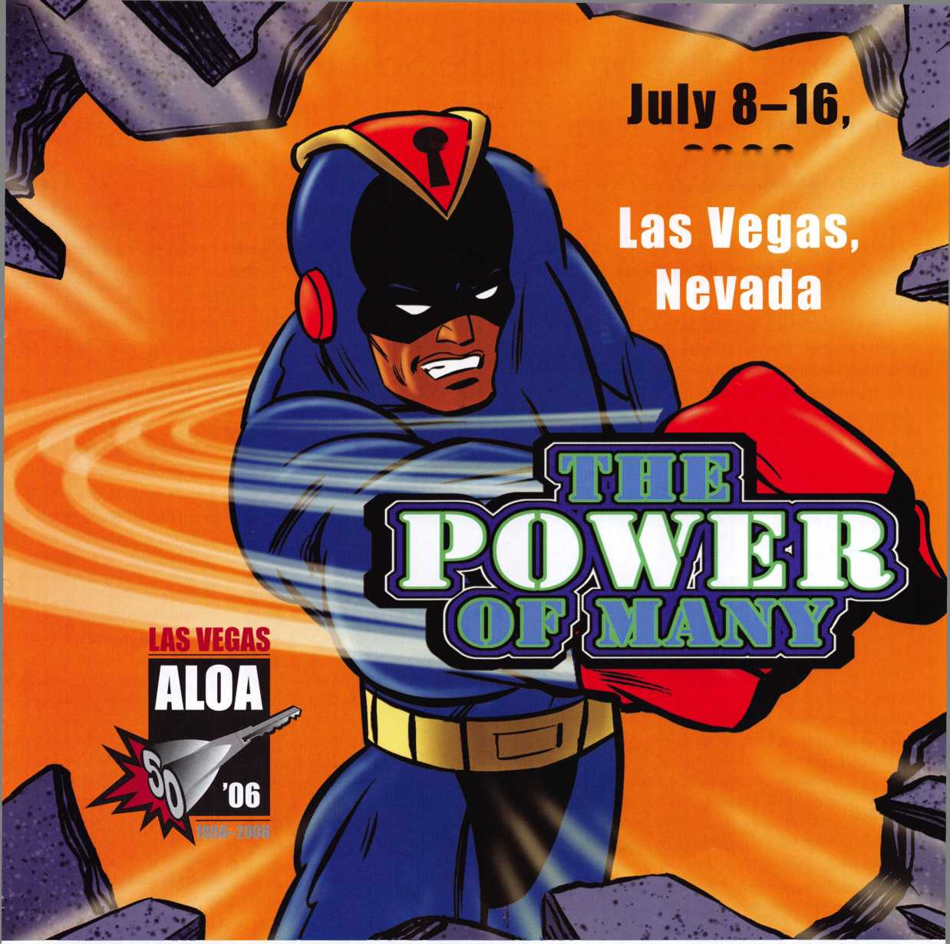

Thomas Jefferson Middle School Wraps Modern Functions in Traditional Architecture

By Ray I. Scroggins, APR

Wrapped in traditional architecture that pays homage to its  
namesake, the new Thomas Jefferson Middle Schools interi-  
or space is developed around the teaching and learning needs  
of the 21st century. The building is structured with class-  
rooms located around cooperative learning spaces, where stu-  
dents can flow into or out of the classrooms as they work on  
projects individually and in groups. At the same time, the  
facility addresses security concerns in an effective yet unob-

trusive manner.

The 140,000 sq. ft.  
middle school,  
which opened in fall  
2004, was designed  
to serve approxi-  
mately 850 students  
in grades six through  
eight. It is part of  
the Vancouver  
School District,  
located just across  
the Columbia River  
from Portland,

Oregon. The district  
includes 21 elemen-  
tary schools (K-5),  
seven middle schools  
(6-8), and six high

schools (9-12), serving a total enrollment of more than  
22,000 students

The schools unique design incorporates a host of features  
crafted to protect students, teachers, and equipment while  
providing convenience and functionality to its users. Todd  
Horenstein, Assistant Superintendent of Facilities and  
Capital Projects at the Vancouver School District, says that,  
rather than trying to coordinate the hardware with the  
schools traditional exterior, it was selected for function and

durability. He adds, “We also wanted to maintain consisten-  
cy with the other schools in the district. We have our own  
locksmith and take care of our own maintenance, so we like  
to standardize. It limits our inventory and helps our people  
to be more proficient.”

Hardware Applications Illustrate Functionality

The schools open design creates opportunities for interac-

tion and teambuild-  
ing, and minimizes the  
use of corridors and  
fire stairwells that are  
found in typical  
school designs.

Because of the facility’s  
unique floor plan,  
security and life safety  
also received custom  
solutions. Horenstein  
explains, “We have a  
num ber of exterior  
doors around the  
buildings perimeter,  
but only a few of them  
actually have keyways.  
They’re basically exits  
and not intended as

points of access.” He says that all students enter the school at  
the main entrance, which is unlocked during the time they  
arrive but locked the rest of the day. “Visitors who arrive at  
other times come into a vestibule and go right from there to  
the main office. They have to check in at the office before  
they are allowed out through secondary vestibule doors and  
into the main building.”

Outside of school hours, authorized faculty and staff mem­bers can gain entrance to the building with a proximity card access system that releases the electric latches on Von Duprin

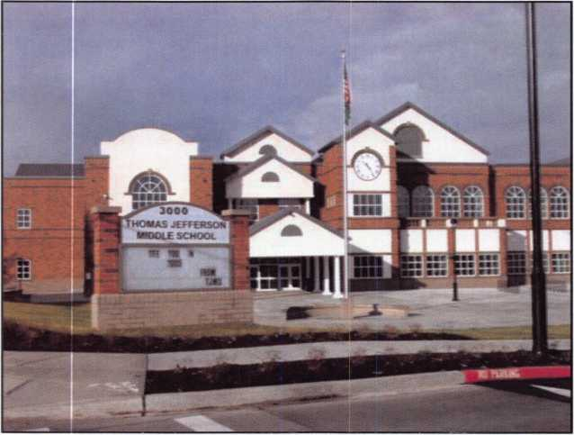

**22**

Keynotes • November 2005

99EL exit devices. The same system also provides for a rapid one-button lockdown from the office reception area if neces­sary. LED lights on the switch plates indicate red if locked and green if unlocked.

Accessibility for people with disabilities is provided at the main entry and several other strategic locations using LCN 4822 pneumatic door operators activated by pushbuttons. The outside actuators also are controlled by the emergency lockdown system and are turned off during a lockdown, as well as after school hours. Von Duprin 9547 exit devices provide safe egress at all times.

Inside the building, corridor doors are equipped with Von Duprin INPact recessed exit devices. These doors are nor­mally held in the open position by LCN SEM 7850 elec­tromagnetic holders that are integrated with the fire alarm system. If the alarm system is activated, they will release and allow the LCN 4011 door closers to shut the doors. When the doors are open, the recessed exit devices project into the corridor less than standard exit devices. These “less bottom rod” devices meet code requirements while eliminat­ing the need for floor strikes, which are hard to clean and unsightly.

Other hardware applications include Schlage ND cylindrical locks, Locknetics key and push switches and power sup­plies, Ives flush bolts, coordinators, kick plates and stops.

Defining the Process

The project manager was Dave Butts, of LSW Architects, a Vancouver-based firm that specializes in educational architecture. General contractor was Robinson Construction Co., a full-service construction management and general contracting company based in Portland,

Oregon. Hardware was furnished through Benson Industries, also of Portland.

Butts states that LSW has been Vancouver School District's primary architectural service provider for the past 15 years. He notes that the firm employs the symposium or design charette process on its educational projects. “This process, collectively fine-tuned by Vancouver Schools and LSW Architects, is the cornerstone of the design effort and of the community interaction that is sought on each project.” The design team believes that a better, more functional, more responsible, and more enduring product comes out of this approach. Having employed this technique on more than

sixty independent projects, LSW is also convinced that  
school pride among staff, students, and parents rides high-  
est, and that the community is much more satisfied with the  
school, when this teamwork approach is fully embraced.

According to Butts, the VSD’s forward-thinking Board of  
Directors deserves credit for much of the school’s design suc-

cess. He says, “Driven  
partially by new ideas  
that came out of the  
symposium/design  
charette and partially by  
their own educational  
concepts, the Board did  
push for some site-spe-  
cific amenities and fea-  
tures that are now show-

cased at TJMS. Among the highest priorities was the need  
for a safe and secure building. At TJMS, this meant a secur-  
able entry system design that forces visitors to engage with  
school administration before any exposure to the students or  
staff is possible. It also meant that both the internal circula-  
tion and each classroom would need to be securable at a  
moment's notice. Electronic monitoring and access controls  
are now integrated throughout the facility. A security staff

member has been  
added, with all the  
tools of observation,  
control, and reaction  
close at hand.

Materials used in the  
building and choices  
for hardware manu-  
facturers, equipment  
and vendors have also  
District Preferences (a

response to what has worked best for this particular owner  
over the years and within dozens of projects), 2. Product  
Compatibility to existing systems (so that functions such as  
monitoring, balancing, and keying can be accomplished effi-  
ciently), and 3. Satisfaction with LSW's own 'green' specifi-  
cations for environmental and clean air materials and appli-  
cations. Butts concludes, “Our specifications and construc-  
tion details have been designed to meet LEEDTM require-  
ments and State programs for many years now."

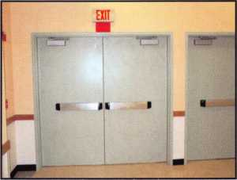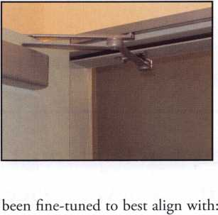

Keynotes • November 2005

**23**

Products, Service, Marketing

By: Claire Cohen



Have you added a new product line to your inventory? Do you now offer a new service?

After investing research time and money to buy new equip­ment and/or products for your business, do you believe that is ALL you need to do to take additional revenues to the bank? It may be time to analyze your advertising and pro­motion plans and update your marketing strategy.

Opportunities to increase profits with your new products and services may definitely be present. As a security pro­fessional in the industry, it will be your mission to show

your expanded capabilities to current customers and poten­tial customers. You will need to demonstrate the advan­tages of the new products and services you offer and how you can integrate this into your present business.

Many security professionals will find niche markets for their new products and services. The key to getting the most out of your current markets as well as expanding new avenues for revenue involve updating your promotion



Keynotes • November 2005

Email: glmperry(a)iwuisp.com for unlock code Greg Perry 2003



SafeData

Greg Perry, CML, CPS

Open up your library! SafeData allows you to find the information you've  
invested in, fast.This one program has over 8500 listings of magazine, books,  
ClearStar Security Network posts and my personal library. Each listing includes not  
only the book or magazine, the issue, the title, the author and the page, but it also  
lists the lock and the hand of the lock (when available). SafeData lists patent dates  
and other trivia that may help in identifying a container or lock.

SafeData also has picture folders representing over 90 different manufactures of  
safes and locks with over a thousand pictures. Some models include a text file giv-  
ing general information on size and relock locations. Plus you can add your own  
information and update it yourself or purchase the annual updates.

SafeData is available exclusively from ALOA. Normal price for this CD is $249.95.  
Price includes two installs! Put it on your desktop and your laptop.

Special Introductory offer

includes your first update!

**$**199.95

To order contact ALOA (800) 532-2562

plans. You need to let your customers and potential cus­tomers know who you are, what you do and why they will benefit from your products and services. There are a vari­ety of ways to accomplish this. The following are a few suggested methods.

Depending on the nature of your business, geographical location, and the type of customers you wish to serve (i.e. residential, commercial, automotive), there are numerous options for advertising including local phone books, news­papers, trade journals, activity programs, calendars, indus­try directories, radio/television ads as well as on-line opportunities. When and how you advertise will depend on the variety of factors. Advertising is usually expensive and careful examination of where to advertise is impera­tive. Before you place any ads, think carefully about your updated strategies. What information do you want your customers or potential customers to see and hear about your business NOW?

For print ads, develop draft content in-house. Work with advertisers to enhance the graphics and design of your ads. If your budget allows, local radio may create marketing opportunities. Always track the leads you receive from each type of media so that you can adequately evaluate the results. Make sure you give the ads sufficient time to pene­trate your market before evaluating their value.

Direct mail is another popular method for promoting your business. There are a variety of direct mail choices that could work well for your business. Company newsletters, postcards, flyers and letters can all be used. Highlight product offerings, specials, new capabilities and company news. For optimal results, mail only to identified prospects or prior customers, and have a follow-up plan in place prior to the mailing. Some direct mail advertisement fliers can also be included with the invoices or left at the cus­tomer site for future reference.

Networking can sometimes yield profitable business con­nections. Such opportunities include membership in local associations, such as locksmith groups, chambers of com­merce, rotary clubs, trade associations and special interest

groups. Does your business provide a service that could be of value to another security-related organization? If you are going to join a group for the purpose of making legiti­mate business contacts, keep in mind that it pays to get involved to maximize opportunities. Always carry plenty of business cards!

Take advantage of free publicity in your area by submitting stories to local papers and other publications. Some ideas can include new product lines or expanded services, facility changes, or a notable job you are doing in your locality.

Your BEST source for new customers should always be referrals. Treat your customers well and they will refer oth­ers to you. Some companies even make the extra effort to ask for referrals from their customers and other contacts.

If your business has a storefront or showroom, make the most of it. Use it to display your new product and/or announcing your new service. CHANGE SIGNAGE PERI­ODICALLY! Include seasonal items, such as back-to-school padlocks, fire-resistive containers for tax time. You can also place fliers and direct mail pieces in your store customer area, in a prominent area to promote your new ventures.

It pays to have a website, provided you do it right. You may want to hire a service to host the website and position it for you. Getting your website properly positioned with search engines means that it will be seen by the desired audience. With advances in software, websites may be easy to create; but, getting it to be seen is another story. It may be worth the cost to make sure that it is done right. A professionally-designed website does you little good if it is not seen and used.

When evaluating your business strategy, you will want to target your current customers as well as potential cus­tomers. How you do so will depending on many factors. Always use a creative mix of advertising mediums, and evaluate and update often. This will ensure maximum exposure for your company and die products you sell and service. Take the time, make the effort, and reap the results of your new marketing strategies!

**26**

Keynotes • November 2005

The Doctor Is In

By Brian Costley, CPL

The doctor in question would be Daniel M. Graffeo, PhD, aided by his lovely assistant Matt McManis. IVe known Dan for about twenty years, and he never fails to impress me with his wealth of knowledge over a wide range of topics. And I don’t impress easily anymore. Dan explores any subject that catches his interest in a painstakingly methodical manner that attests to his background (and continuing interest) in medicine. He is a practicing clinical psychologist who began his medical career as an anesthetist. This would represent a full and satisfying career for most humans, but not for Dr. Graffeo. Most of us know him as a living encyclopedia of vault door and safe lock information, and primarily as THE authority on time locks and movements. If I have to list Dan’s credentials in this area to you, it’s clear you’ve only been in the safe industry an hour or so.

I’ve been fortunate enough to endure two time lock classes taught by Dr. Graffeo. Fortunate because of the quantity and quality of information heaped on me, and taxed by Dan’s unrelenting insistence for perfection, not to mention his fondness for practical jokes in the classroom. If there’s a Dan Graffeo time lock class in your past, you know exactly what I’m talking about. Your memories are an aromatic mixture of pleasure and pain, and you absolutely did learn some­thing. . .a lot of something.

Dan doesn’t teach as much as he used to, but he was coaxed into presenting a four-day time lock class at the most recent ALOA convention, in Chicago. A fortunate and plucky few got seats. The rest of us didn’t fare too badly, either, because a byproduct of the class is a new 144-page manual, “Timelock Servicing Fundamentals.” The table of contents lists:

Section 1: Design & Function—Nomenclature

Section 2: Hand & Ultrasonic Cleaning Timelock Movements

Section 3: Cleaning & Lubricating TMI 104 Series Movements - Servicing 3rd Wheel Clutches

Section 4: Servicing & Lubricating Diebold 120 Hour Movements

Section 5: Servicing Mosler Timelock Movements

Section 6: Servicing SG Standard, Reset & Snap-Action Movements

Section 7: Servicing STB Model 114M Mechanical Movements

Section 8: Servicing RelhorAR-165-2 Series Accelerated- Action Movements

Section 9: Servicing S&G 6205 Timebination DAT Movements

Section 10: Servicing, Testing and Troubleshooting 114E and 134W Electronic Movements

The topics listed in the contents cover the most common devices that a technician is likely to encounter, and Dr. Graffeo has hinted that more manuals are on his to-do list, so it’s likely the less common (and therefore more interest­ing) movements will be thoroughly explored in the future.

Dan’s methodical nature translates into thorough, well organized works. The logical progression is terminology, pieces and parts, generic cleaning equipment and its uses, model-specific movement cleaning and lubricating proce­dures, and information on when and how to adjust critical components. There is also detailed servicing and trou­bleshooting information for the 114E and 134W electronic time lock movements.

As you might expect, each of the cleaning and lubrication procedures is presented in a step-by-step format. As I was reading through the manual and thinking about Dan’s logi­cal step-by-step approach, I was reminded of a story told to me years ago by an acquaintance name Ken. Ken and his wife traveled to Oklahoma to visit relatives they had not seen for many years. One of these extended family members was the wife’s white-haired, country doctor uncle. He had a sec­ond floor, walk-up office that could have been right out of a

Keynotes • November 2005

**27**

movie from the 30s or 40s. While chatting with the wizened old doctor, Ken mentioned that he had been thinking about having a vasectomy, but had reservations. Doc, in his best bedside manner, explained that it was a simple procedure, and that if Ken wanted to have it done, Doc would do it himself, free of change, after his regular office hours the fol­lowing Saturday. The word “free” always did strike a chord with Ken, so he readily agreed.

Saturday afternoon, Ken found himself lying on the examin­ing table in Doc’s small office, wearing only a surgical drape from the waist down. After the local anesthetic took hold, Doc, in a slow and very deliberate manner, began the proce­dure. Meanwhile, Ken was trying to concentrate on any­thing other than what was happening in his 4 southern hemi­sphere.” After awhile, however, he noticed that Doc would often pause in his work to consult a large medical book lying on a nearby desk. Holding a scalpel in one hand, the index finger on his other hand would seek out what he was looking for on the open page. After observing this a few times, Ken began to feel uneasy.

“Doc, can I ask how many vasectomies youVe performed?’

“Well, son, to be perfectly honest with you, this is the first time Ive ever tried it.” Pointing to the open medical book, he added, “But its so simple, you couldn’t hardly screw it up.”

Yes, step-by-step instructions, illustrated where necessary, are a very useful thing. And the same type of thinking that went into the medical book that guided Doc through his first vasectomy also went into “Timelock Servicing Fundamentals.” The subject is presented so logically that you can’t hardly screw up. Keep in mind however, that Doc had umpteen years of medical school, residency, and practi­cal day-to-day experience before he ever attempted his first by-the-book vasectomy. Likewise, you would be foolish to believe that you could read Dr. Graffeo’s manual and be instantly qualified to service delicate time lock movements. This is a training and reference manual for those who have made the pilgrimage to the classroom, or who have studied the art of time locks under a qualified mentor.

As you read through “Timelock Servicing Fundamentals,” it soon becomes apparent that this isn’t just a cut and dry tech­nical manual that explains which part goes where. Variations of particular movements are discussed and sometimes illus­

trated in photographs. There are also bits of industry history sprinkled through the manual; tidbits that are intended to explain why devices were changed, or why a manufacturer abandoned, then re-entered the time lock business. Think of these pieces of information as the twine that binds the tech­nical stuff together and humanizes it. I enjoy this aspect of the manual as much as anything.

Publishing technology has changed dramatically in the last twenty years. Dr. Graffeo and I both date back to the days when magazines, books, and manuals were created with the use of typesetters, paste-ups, rubylithe, and numerous other arcane tools. In the hands of an experienced and skilled printer, the results were very, very good. They were also very expensive and very time consuming, so a lot of useful infor­mation did not get published.

Today, all you need is a decent computer, some moderately priced software, and a printing vendor who can accept elec­tronic files (and they all can these days). These marvelous tools allow the determined individual to create, illustrate, lay out, and print very nice publications. Dan Graffeo, along with help from Matt McManis, has utilized the flexibility and convenience digital photography, CAD, and desktop publishing software to create a technical manual that is clean, easy to read, and well illustrated. Dan has even gone the extra mile to print it in color. This makes the photo­graphs easy to interpret at a glance. Much as I admire the vividness of black and white photography, it simply cannot convey the same amount of information as color can in a technical publication. Color helps the reader intuitively identify materials and recognize surface boundaries.

“Timelock Servicing Fundamentals” is an investment at $225. In reality, it’s a small amount of money for the life­time of research that has gone into its making. This is the definitive book on time lock servicing by the acknowledged master of the subject. Your technical library is a bit light without it.

Dr. Graffeo’s “Timelock Servicing Fundamentals” is currently available direct from Dan at TMI (785-232-8705), or you can obtain if from Timemaster (888-798-8465), Mark Bates Associates (888-622-5495), or Lockmasters (800-654-0637).

**28**

Keynotes • November 2005

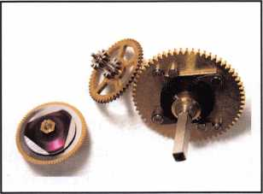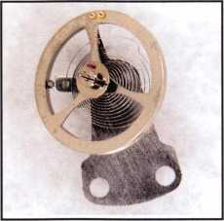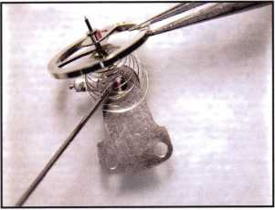

The clarity and detail of this photo of a 1st, 2nd, and 3rd wheel from a time lock movement are remark­able. There’s no mistaking the fact that the 3rd wheel incorporates a clutch mechanism to allow back- winding of the movement. This is the kind of stuff you’ll learn from “Timelock Servicing Fundamentals.”

Some of the close-up pho­tography in the manual is not only instructive, it’s pretty remarkable. This shot of a balance assem­bly shows the balance spring and roller jewel in vivid detail.

Step-by-step instructions, com­bined with photos such as this one of a syringe being used to flush solvent into jewel, provide very good instruction on movement cleaning.

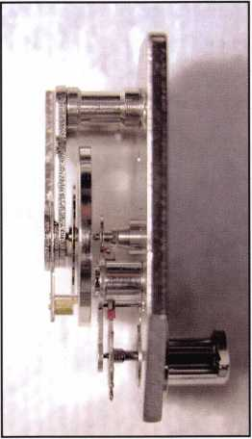

This view is from the side of aTMl 104Y escapement. The color photography makes it simple to identify the jewels, which are a bright red/purple.

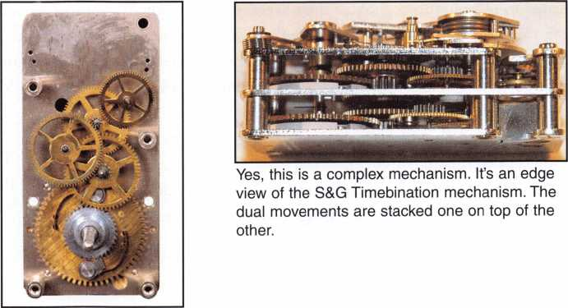

To illustrate the quality of  
the photographs in  
“Timelock Servicing  
Fundamentals,” what  
could be better than an  
actual photo from the  
book? This is a shot of  
the S&G 144 hour  
movment’s gear train, with  
all five wheels in place on  
the bottom plate.



Keynotes • November 2005

ALOA Members Band Together To Help Those In Need

When any kind of disaster strikes, an instant opportunity arises for people to band together to give aid to those in need. Over the last months this has been the case all over our country, as several hurricanes made their presence known by crashing into the coastal regions of the United States. National, state, and local organizations have mobi­lized to offer support to those who lost many, if not all of their material possessions. The Associated Locksmiths of America have also had many of its’ members affected by these great storms and therefore recognized the need to take advantage of our large membership to support our fellow locksmiths.

After the damage of hurricane Katrina had been assessed, ALOA took action by constructing a website completed ded­icated to helping those who lost their livelihood. Many of our members in the affected areas lost their shops and tools, and many of them lost their homes. This website offered a point of contact for members all over the country to offer assistance to those who needed it most. More than 30 companies and individuals logged on to offer employment. Others offered both employment and housing and some offered equipment and tools. Along with jobs and housing, many of our members took advantage of our online dona­tion system to give monetarily.

In light of the response to this disaster, ALOA has decided to make this an ongoing effort to provide relief for those mem­bers who face unexpected hardships. The ALOA Disaster Relief Fund will serve to offer financial assistance to those who face disasters of any kind, whether it is a natural disas­ter such as Katrina or another loss such as fire - or even extraordinary circumstances such as terrorist attacks. Already some of the money we have received has gone to help pay dues for those who have endured hardship from Katrina. This assistance has been greatly appreciated.

Getting involved is simple. If you have access to the internet, simply log on to the ALOA store at <http://www.aloa.org/store> and click the icon for the Disaster Relief Fund. You can choose the amount you would like to donate by adding the proper amount to your online basket. If you do not have access to the internet or would simply like more information about this ongoing effort, please call the ALOA headquarters at 214-819-9733 or toll free at 800-532-2562.

Remember, ALOA can only continue these kinds of efforts with the support of our members. Let’s all come together and do our part to make this association stronger and more helpful to everyone involved!

**30**

Keynotes • November 2005

.29.95

.19.95

.19.95

.29.95

.29.95

29.95

.79.00

.45.00

.85.00

.19.95

.29.95

.19.95

.29.99

.19.95

.55.00

.39.95

.89.95

.39.95

...25.00

...27.00

...19.95

...39.95

...14.95

...34.95

...45.00

...29.95

175.00

175.00

9.95

...99.00

155.00

1. ...59.95 1 10.00 110.00 ...95.00 ...95.00 ...39.95 ...29.95 ...29.95 ...29.95 ...29.95 ...29.95 .. 29.95 ...29.95 ...29.95 ...29.95 ...29.95 ...29.95 ...29.95 ...99.00 ...99.00 ...29.95 .115.00 ...69.95 ...14.95 ...27.00 ...25.00

...25.00

.595.00

of Our Titles...

Learn About Basic Electricity

Spacing and Depths, vol 1

Spacing and Depths, vol 2

Filing for Dollars

Antique Padlocks

VATS Made Simple (Revised)

Guide to Transponders

2000 Transponder Update

Bread & Butter

Locks and Lockmakers of America

Learn About Electronic Locking Devices

The Best of Locksmithing, vol 1

Logical Lock Diagnostics

How to Pick Lever Locks

Fundamentals of Master Keying

Guide to Electronic Locksmithing

Security Solutions Locksmith Marketing Program The Ultimate Techtips Collection

Locksmithing from Apprentice

to Master

Wafer Lock Reading

Door Lock Encyclopedia

Lock Repair Manual

Interchangeable Core Cylinders

Picking & Impressioning

The Lure of the Lock

High Security Safes, vol 1

High Security Safes, vol 2

Safeman's Guide, vol 13

Safe Deposit Depth and Space Manual

Safe Technician's Reference Manual

Gun Safes

Modern Safe Opening

Dave McOmie on Vault Doors, vol 1, Bank Vaults

Dave McOmie on Vault Doors, vol 2, Fire and Plate Vaults ...

Modern Safe Locks

Drilling Safes

Safe Deposit Box Service

Foreign Car Impressioning Book

Impressioning Ford and GM Side Bar Locks

Automotive Lock Servicing Update #1: GM 10-Cut Locks

Automotive Lock Servicing Update #2: GM 10-Cut Locks

Automotive Lock Servicing Update #3: GM 8-Cut Locks

GM Locks: Perfect for the Beginning Locksmith!

Ford Locks: Pin Tumbler and Ten-Cut Systems

Chrysler Pin Tumbler Locks

Chrysler Double-Bitted Locks

Toyota Split-Tumbler Locks

Basic Door Panel Servicing

Advanced Door Panel Servicing

Motorcycles on CD

The Guide to Motorcycles

Japanese High Security Auto Servicing

Revised GM Steering Column Course

Foreign & Domestic Auto Service

Auto Lock Service

The Sieveking Auto Key Guide & Illustrated Cross Reference

Servicing Interchangeable Cores—Sargent

Servicing interchangeable Cores—Arrow, Best,

Eagle, Falcon, and Lockwood

The Ultimate CCTV Program on CD Rom

**Visit the new-and-improved ALOA Store to view more available titles.  
Place your order online or by phone today!  
[www.aloa.org](http://www.aloa.org) • (214) 819-9733* Please allow 3-4 weeks for delivery.**



United States Postal Service

Statement of Ownership, Management, and Circulation

|  |  |  |
| --- | --- | --- |
| 1. Publication Title  Keynole s | 2. Publication Number | 3. Filing Date  OcJr. 1, ZOOS |
| 0T.11. 01^2 |
| 4. Issue Frequency  MOntKIy £b»m<ytthly July / Aug) | 5. Number of Issues Published Annually  II | 6. Annual Subscription Price  member bene fi b |
| 7. Complete Mailing Address of Known Office of Publication (Not printer) (Street, city, county, state, and ZIP+4)  3500 Easy Street  Dallas tv | | Contact Person  EeHv l-f end or Son |
| Telephone  2iu-m-<n3 3 |

8. Complete Mailing Address of Headquarters or General Business Office of Publisher **(Not printer)**

SOmc

**9. Full Names and Complete Mailing Addresses of Publisher, Editor, and Managing Editor (Do not leave blank)** Publisher **(Name and complete mailing address)**

**SO** nv£

**Editor** (Name and complete mailing address)

Betty l+dndflOoo

**3500** €<XS**y** SW(tb TV IS**?Ml**

**Managing Editor** (Name and complete mailing address)

**S** amt

**10. Owner** (Do not leave blank. If the publication is owned by a corporation, give the name and address of the corporation immediately followed by the names and addresses of all stockholders owning or holding 1 percent or more of the total amount of stock. If not **owned** by a corporation, give the names and addresses of the individual owners. If owned by a partnership or other unincorporated firm, give its name and address as well as those of each individual owner. If the publication is published by a nonprofit organization, give its name and address.)

|  |  |
| --- | --- |
| Full Name | Complete Mailing Address |
| Assooiahcl Locksmiths e>t A | 3Soo easy si reel baiiaj nr isim |
|  |  |
|  |  |
|  |  |
|  |  |

11. Known Bondholders, Mortgagees, and Other Security Holders Owning or  
Holding 1 Percent or More of Total Amount of Bonds, Mortgages, or

Other Securities. If none, check box  **-**  ► □ None

|  |  |
| --- | --- |
| Full Name | Complete Mailing Address |
|  |  |
|  |  |
|  |  |
|  |  |
|  |  |

**12. Tax Status** (For completion by nonprofit organizations authorized to mail at nonprofit rates) (Check one)

The purpose, function, and nonprofit status of this organization and the exempt status for federal income tax purposes: □ Has Not Changed During Preceding 12 Months

**□ Has Changed During Preceding 12 Months** (Publisher must submit explanation of change with this statement)

PS Form 3526, October 1999

(See Instructions on Reverse)

|  |  |  |  |  |
| --- | --- | --- | --- | --- |
| 13. Publication Title  XgynoiM | | | 14. Issue Date for Circulation Data Below  SeoVemhef Zoos | |
| 15.  Extent and Nature of Circulation | | | Average No. Copies Each Issue During Preceding 12 Months | No. Copies of Single Issue Published Nearest to Filing Date |
| a. Total Number of Copies (Net press run) | | | 7100 | 11 00 |
| b. Paid and/or Requested Circulation | (1) | Paid/Requested Outside-County Mail Subscriptions Stated on Form 3541. (Include advertiser's proof and exchange copies) |  | 0445 |
| (2) | Paid In-County Subscriptions Stated on Form 3541 (Include advertiser's proof and exchange copies) | 0? | 0 * |
| (3) | Sales Through Dealers and Carriers, Street Vendors, Counter Sales, and Other Non USPS Paid Distribution | 0 | 0 |
| (4) | Other Classes Mailed Through the USPS | 0 | 0 |
| c Total Paid and/or Requested Circulation ^  [Sum of 15b. (1), (2),(3),and (4)] V | | | U 5 b 3 | 0>S U |
| dFree Distribution by Mail (Samples, compliment ary, and other free) | (D | Outside-County as Stated on Form 3541 | 0 | 0 |
| (2) | In-County as Stated on Form 3541 | 0 | 0 |
| (3) | Other Classes Mailed Through the USPS | f) | . 0 |
| e- Free Distribution Outside the Mail (Carriers or other means) | | | 4 5 0 | ?oo |
| f.  Total Free Distribution (Sum of 15d. and ISe.) ^ | | | 4 50 | ?oo |
| ® Total Distribution (Sum of 15c. and 15f) ^ | | | 10 | 3 | 7305 |
| h.  Copies not Distributed | | | on | 5 37 |
| Total (Sum of 15g. and h.) ^ | | | 11 00 | 11 O 0 |
| i- Percent Paid and/or Requested Circulation (15c. divided by 15g. times 100) | | | <?3,52>% | ?4. !3°/o |

16. Publication of Statement of Ownership

Publication required. Will be printed in the **QOOS** issue of this publication. □ Publication not required.

17. Signature and Title of Editor, Publisher, Business Manager, or Owner

Date

J 0\ | I $

I certify that all information furnished on this form is true and complete. I understand that anyone who furnishes false or misleading information on this form or who omits material or information requested on the form may be subject to criminal sanctions (including fines and imprisonment) and/or civil sanctions **(including civil penalties).**

Instructions to Publishers

1. Complete and file one copy of this form with your postmaster annually on or before October 1. Keep a copy of the completed form for your records.

. 2. In cases where the stockholder or security holder is a trustee, include in items 10 and 11 the name of the person or corporation for whom the trustee is acting. Also include the names and addresses of individuals who are stockholders who own or hold 1 percent or more of the total amount of bonds, mortgages, or other securities of the publishing corporation. In item 11, if none, check the box. Use blank sheets if more space is required.

1. Be sure to furnish all circulation information called for in item 15. Free circulation must be shown in items 15d, e, and f.
2. Item 15h.. Copies not Distributed, must include (1) newsstand copies originally stated on Form 3541, and returned to the publisher, (2) estimated returns from news agents, and (3), copies for office use, leftovers, spoiled, and all other copies not distributed.
3. If the publication had Periodicals authorization as a general or requester publication, this Statement of Ownership, Management, and Circulation must be published; it must be printed in any issue in October or, if the publication is not published during October, the first issue printed after October.
4. In item 16, indicate the date of the issue in which this Statement of Ownership will be published.
5. Item 17 must be signed.

Failure to file or publish a statement of ownership may lead to suspension of Periodicals authorization.

PS Form 3526, October 1999 (Reverse)

ShniiiM

**T RETROFITS VIRTUALLY ANY DOOR AND HAS ALL THE STYLE AND**

**SECURITY HOMEOWNERS WANT. That’s WHY IT’s ALL YOU NEED TO CARRY.**

*Introducing the Schlage* Accents

Schlage now provides you with the ability to retrofit virtually any door with the ultimate in elegance and security. The Schlage Accents collection is built on a revolutionary chassis designed to provide field-reversible levers on passage, privacy and now keyed functions. A patented adjustable through-bolt allows Schlage Accents handlesets to retrofit over 70% of competitors’ current designs. Special features like these, along with concealed screws and decorative trim, allow you to reduce the inventory you carry while providing the perfect door hardware choice for homeowners who desire Schlage quality and security.

*Collection*

To find out more about the finest line of decorative door hardware, visit schlageaccents.com.

**business**

HHPMKMI

**© 2005 Ingersoll-Rand**

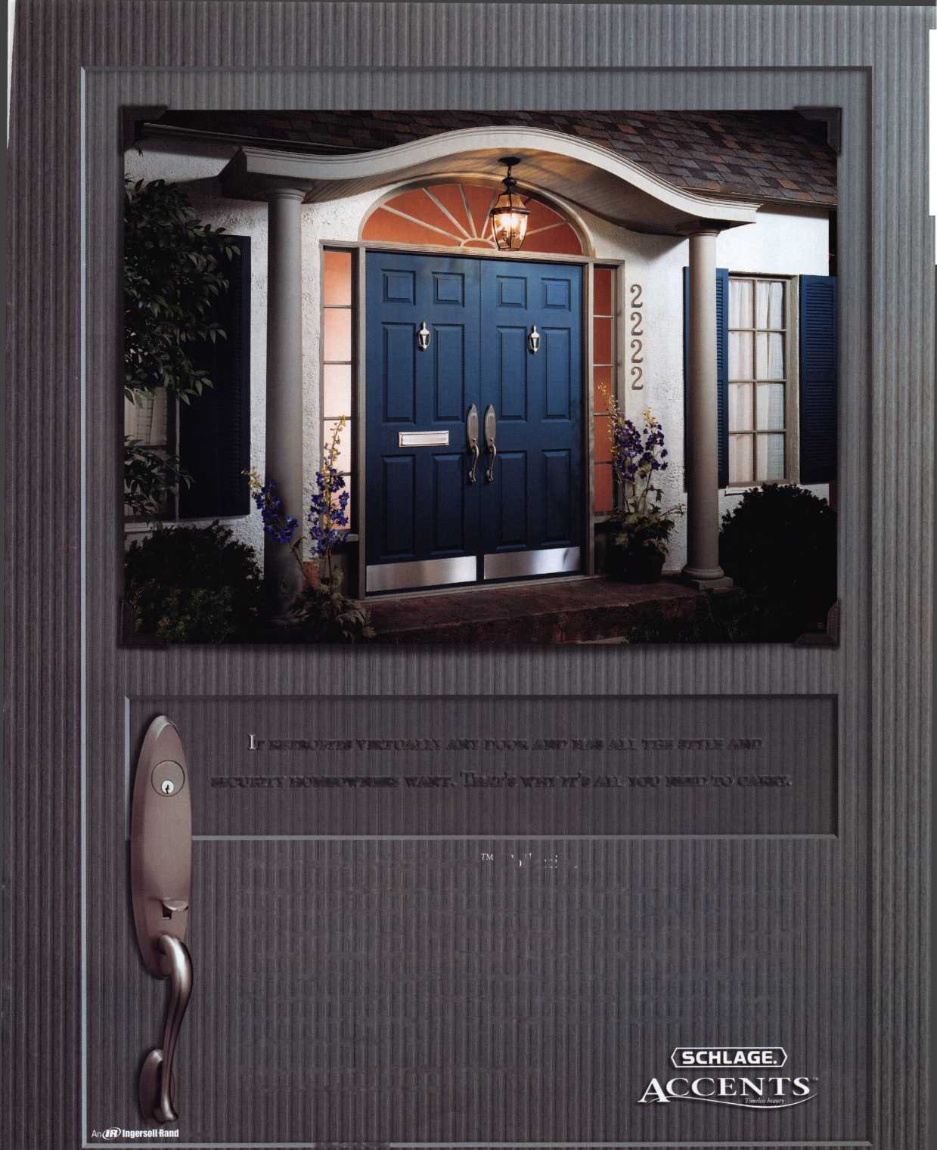

call me.

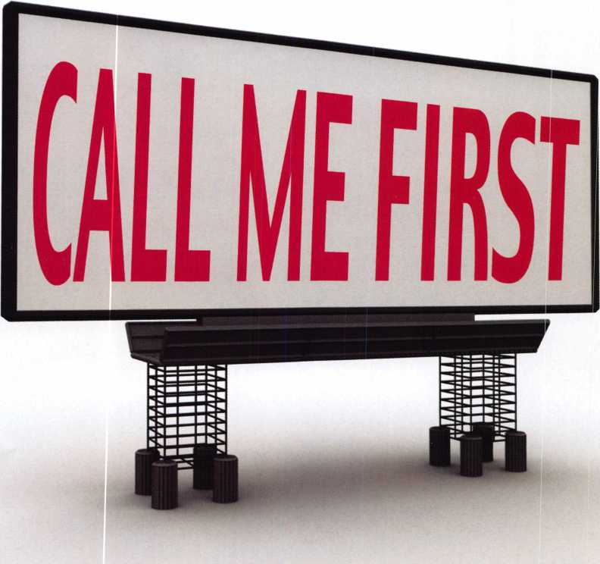

which one catches your attention?

Bigger is sometimes better. And when someone is in need of your services, you want to take every opportunity to make your name prominent in the minds of searching consumers.

Introducing a new advertising solution from ALOA. At our new public locksmith search site, findalocksmith.com, you can now purchase an ad for your business that will shine brightly on the results page whenever someone searches for a locksmith in your zip code. The initial cost is only $30.00, and each additional zip code you add is only $5 extra. Don't miss this great opportunity!

Call Kim Hammond at 817-645-6778 for details.

Spaces for each zip code are limited. Call to reserve yours now!

*coIojl mCd*

*Spurns*

***to life...***

*also amiabk:*

Black Fire Engine Red

Pewter Purple Grape

Bright Nickel Construction Orange Brass Plated Cobalt Blue Hot Pink

Prevents Surreptitious Entry at Airports.

Know when your bag has been searched by a TSA agent or violated by an unknown person.

**SearchAlert®**



Recognized by the TSA

Security Window

lock has been opened lock not opened

**TRAVEL SENTRY**

CERTIFIED

Security Products

301 West Hintz Road • Wheeling, IL 60090 800.733.8588 • Fax: 847.537.1881 • [www.cclsecurity.com](http://www.cclsecurity.com)

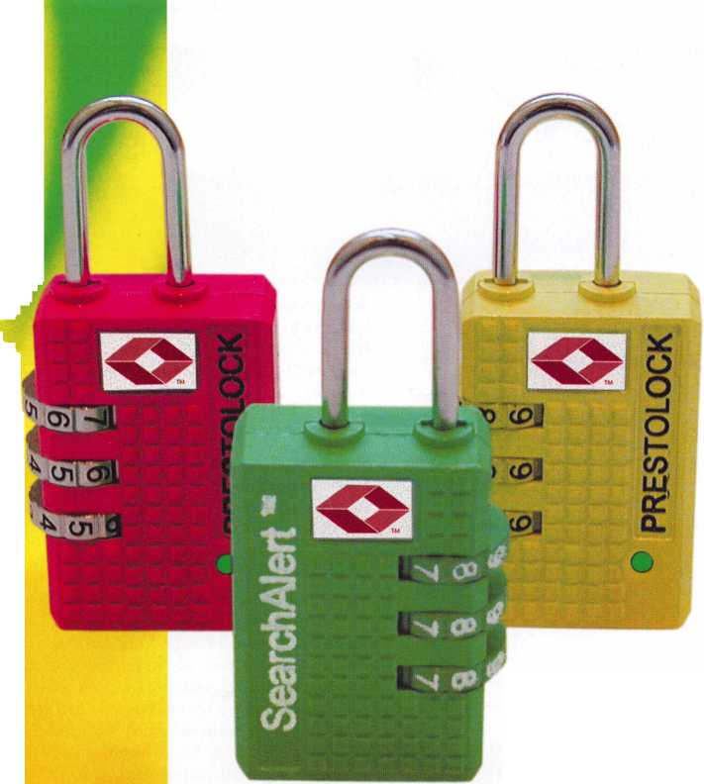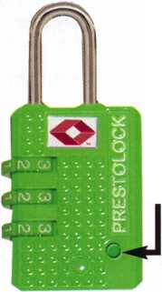

**Classifieds**

I

EMPLOYMENT

LOCKSMITH NEEDED

We are a 40-year-old rapidly growing company in need of experienced locksmiths. We provide all the tools, a brand new van, key machines, uniforms...the works. Salary is dependant upon experience and skill, very competative wage and benefits package. Paid Vacation, 401k, medical, cross training in our electronic security division and much more. We know how to treat good employees well. Please send resume or inquiry to [paulbrandon@lockguys.com](mailto:paulbrandon@lockguys.com) or call 253-839-3443

LOCKSMITH NEEDED

Large Lock shop in the Palm Springs area of California is looking for an experienced lock­smith for field work. Must be proficient in master keying, safety deposit boxes and working knowl­edge of safes. Salary plus commission, health insurance benefits, and 401 K plan. Please fax resume to 760-779-1 81 1 or call 760-346-5214.

EXPERIENCED SERVICE TECHNICIAN

sought in established company in Central Illinois. Must have good driving record, positive work habits and be neat in appearance. Our compa­ny offers a competitive salary with an excellent benefit package - many EXTRAS. Mail or Fax resume to: Denny at Dave & Harry Locksmiths, Inc. 1 16 E. University Avenue, Champaign, IL 61820. Telephone: 217-352-5034 Fax: 217-352-3505.

PROFESSIONAL EXPERIENCED LOCK­SMITH/SAFE TENICIANS WANTED:

We are in need of 1 to 2 technicians with the ability to sell, install and service all major manu­factures hardware. We are located in Knoxville,

Tennessee and service all areas of east and mid­dle Tennessee. Must have a clean criminal and driving record. Must have a professional attitude and appearance. Background check and refer­ences must be supplied. Must be experienced in commercial, industrial, and residential hard­ware, sales, service, and installations. Access, SAFE, and other areas ARE a plus. Paid holi­

days, retirement, health insurance, uniforms, tools and truck supplied. 8 am - PM Monday - Friday. Call:865-522-0841 Fax:865-637-2359 Email:[INFO@FMGEORGE.COM](mailto:INFO@FMGEORGE.COM) 800.484.5577 pin 0841

ACCESS CONTROL TECHNICIAN NEEDED

He/she must have 3-4 years experience in Sales & Installation of Electronic access control & cctv Installation & Service. Contact Denny Birt 1-800- 352-5034

LOCKSMITH WANTED

Busy shop in Woburn Massachusetts seeks expe­rienced locksmiths for Auto, Commercial, Residential, Safe and Card Access work. We have a large AAA area which we cover and do transponder and high security keys. Will help train in fields you are not familiar with. Sub con­tractors welcome or we will supply tools and van. Great opportunity for self-motivated individ­ual. Please sign up to join our team. Call John at 781-933-9999 or send resume to: Locks & Keys, Inc., PO Box 222, Woburn, MA 01 801. Thank you for your consideration.

WANTED TO BUY/SELL

CLEANING WAREHOUSE OVERSTOCK MUST GO

Cor-Key knobs for Schlage A/D-line hardware. S&G 6730 like new replaced with digital. Free dial and ring, Van Lock cam locks, pin kit for both cylinders and keys. Large assortment of all items. Please call for quantities and pricing. Liberty Lock & Safe 702-871-5397 ex. 2233.

SAFE DEPOSIT BOX LOCKS,

PARTS AND MORE

Wholesale prices. Reconditioned and new locks. All manufacturers; Diebold, Herring Hall & Marvin, llco, Lefebure, Mosler, S&G, Security Corp & Precision. Also available new replace­ment locks. We have a large stock of parts - doors, bond boxes, hinges, key blanks, full sec­tions and more. Call WBI (954) 484-2404

LOCKSMITH EQUIPMENT AND INVENTORY FOR SALE

Key Machines, key blanks, Inventory - prefer to sell complete, will consider offers on individual pieces. Call M.A. Box 432-448-2832 or 448-634-4808.

FOR SALE

Locksmith Equipment and Inventory: Key Machines, key blanks, inventory - prefer to sell complete, will consider offers on individual pieces. Call M.A. Box 432-448-2832 or 448-634-4808.

BUSINESS FOR SALE

16 year old locksmith business located in Miami, FL. Large commercial account base. Serious inquires only. $375,000.

305 233-4447

BUSINESS FOR SALE

Central Florida Locksmith Business with two fully equipped vans, full inventory, tools, key and code machines, etc. Established customer base since 1983. Leased storefront shop. Gross sales 250K-300K. Priced to sell at 150K. Contact Howard at 407'-933-0722.

LOOKING FOR BOOK

I am looking for The Comprehensive Manual of Locksmithing by Shankle and Shankle. Please contact Earl Karsikas at 651-769-2579 or by mail at 8257 Flyde Ave, Cottage Grove, MN 55016.

BUSINESS FOR SALE

Tired of the rat race? Here's the ideal situation for someone who wants to raise a family in the upper Mid-West or seeks a more civilized envi­ronment and still make a living comfortably. Established in 1980, we specialize in Commercial & Institutional accounts with CCTV, high security locks and access control systems. In the heart of Wisconsin with excellent hospital and one of the nation's largest privately owned medical clinics. Contact Robert M. Dennee', Ace Lock & Security, PO Box 632, Marshfield, Wl 54449, 715-387-3064, [rdennee@tznet.com](mailto:rdennee@tznet.com), fax 715-389-8036.

Classified Advertising Policy

Classified advertising space is provided free of charge to ALOA members and for a fee of $2.00 per word, $40.00 minimum for non members. Classified ads may be used to advertise used merchandise and overstocked items for sale, "wanted to buy" items, business opportunities, employment opportunities/positions wanted and the like. Members or non members wishing to advertise services or new mer­chandise for sale may purchase a "Commercial Classified Ad" for a fee of $4.00 per word with a minimum of $100.00. Each ad will run for two issues. For blind boxes there is a $10.00 charge for members and non members. All ads must be submitted in writing to the Advertising Sales Department via fax at 817-645-7599 or through an email to [adsales@aloa.org](mailto:adsales@aloa.org) by the fifteenth of the month two months prior to issue date. ALOA reserves the right to refuse any classified advertisement that it deems inappropriate according to the stated purpose of the classified advertising section.

**NOW EDGE™ KEY CONTROL KEEPS YOUR CUSTOMERS COMING BACK.**

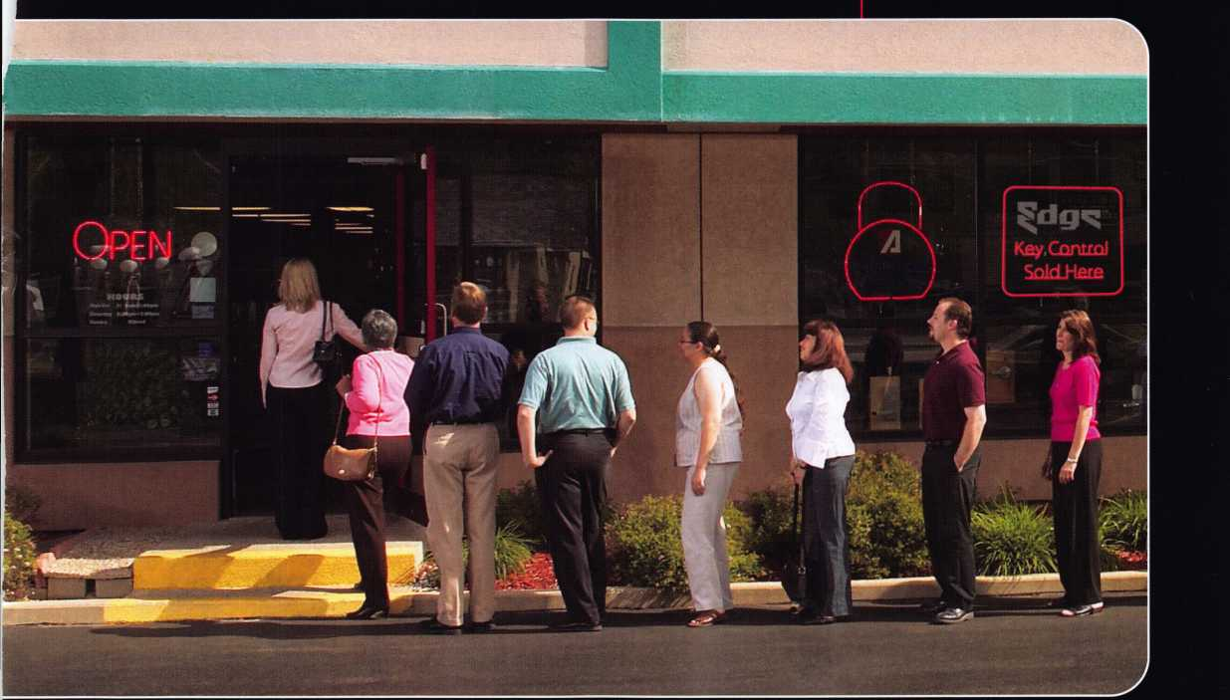

Sfl HP *Introducing Edge*™ *key control:*

^ *the patent-pending system that brings customers back to you — only you — again and again.*

What a great way to gain new customers and lock-in business for years to come!

Unlike costly "high security" systems, Edge lets you offer the kind of security a multitude of businesses need for door locks, padlocks — the works.

No one can duplicate keys without their consent. And no one can duplicate keys for them but you!

**Repeat business you can “own.”**

Edge key control prospects are everywhere — local

restaurants, strip malls, utilities,  
hospitals, municipalities, neigh-  
borhood stores, franchisees ...  
the list goes on.

Edge lets you deliver the

key-control security

they want — and  
can pay for. Year

after year after year.

Ask your distributor about  
Edge key control today.

"now serving!



V J



*Edge fits American Lock® and Master Lock® commercial security products, as well as other makes.*

***The Locksmith's Lock®*** [

© 2005 American Lock Company, a Division of Master Lock Company

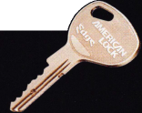

|  |  |  |  |
| --- | --- | --- | --- |
| A | % | ■■■■ ■ | associate |
| 8 | 1 | lHnfl  a | members |

Distributor

**1st In Hardware, Inc.**

Phone: Phone: 410-646-9900 Fax:410-646-0045 www. 1 stinhardware.com

**Accredited Lock Supply Co.**

Phone: 800-652-2835 Fax: 201-865-0030 [www.acclock.com](http://www.acclock.com)

**Andrews Wholesale Lock Supply**

Phone: 717-272-7422 Fax: 717-274-8659 [www.andrewslock.com](http://www.andrewslock.com)

**Boyle & Chase Inc.**

Phone: 800-325-2530 Fax: 800-205-3500 [www.boyleandchase.com](http://www.boyleandchase.com)

**Clark Security Products**

Phone: 888-784-131 1 Fax: 619-718-7333 [www.clarksecurity.com](http://www.clarksecurity.com)

**Cook's Building Specialties**

Phone: 505-883-5701 Fax: 505-883-5704

**Dire's Lock & Key Company**

Phone: 303-294-0176 Fax: 303-294-0198

**Direct Security Supply, Inc.**

Phone: 800-252-5757 Fax: 800-452-8600

**Discount Key Machines.Com/Busch**

Phone: 800-332-8724 Fax: 407-363-4666

**Doyle Security Products**

Phone: 800-333-6953 Fax: 612-521-0166 [www.doylesecurity.com](http://www.doylesecurity.com)

**Dugmore and Duncan, Inc.**

Phone: 888-384-6673 Fax: 888-329-3846

**E. L. Reinhardt Co., Inc.**

Phone: 800-328-1311 Fax: 651-481-0166 [www.elreinhardt.com](http://www.elreinhardt.com)

**Ewert Wholesale Hardware**

Phone: 800-451-0200 Fax: 708-597-0881

**Foley-Belsaw Company**

Phone: 800-821-3452 Fax: 816-483-5010 [www.foley-belsaw.com](http://www.foley-belsaw.com)

**Fried Brothers Inc.**

Phone: 800-523-2924 Fax: 215-592-1255 [www.fbisecurity.com](http://www.fbisecurity.com)

**Hans Johnsen Company**

Phone: 214-879-1550 Fax: 214-879-1530

**Hardware Agencies, Ltd.**

Phone: 416-462-1921 [www.hardwareagencies.com](http://www.hardwareagencies.com)

**IDN Incorporated**

Phone: 817-421-5470 Fax: 817-421-5468 [www.idn-inc.com](http://www.idn-inc.com)

**Instant Hardware Delivery, Inc**

Phone: 800-355-1107 Fax: 800-663-8518

**Intermountain Lock & Supply**

Phone: 800-453-5386 Fax: 801-485-7205 [www.intermountainlock.com](http://www.intermountainlock.com)

**International Electronics, Inc**

Phone: 800-343-9502 Fax: 617-821-4443

**Jo Van Distributors**

Phone: 416-288-6306 Fax: 416-752-8371 [www.jovanlock.com](http://www.jovanlock.com)

**Lockmasters, Inc.**

Phone: 859-885-6041 Fax: 859-885-7093 [www.lockmasters.com](http://www.lockmasters.com)

**Locks Company**

Phone: 800-288-0801 Fax: 305-949-3619

**Locksmith Ledger International**

Phone: 770-886-0800 Fax: 770-889-7703 [www.lledger.com](http://www.lledger.com)

**McDonald Dash Locksmith Supply**

Phone: 800-238-7541 Fax: 901-366-0005 [www.mcdonalddash.com](http://www.mcdonalddash.com)

**Monaco Lock Co.**

Phone: 800-526-6094 Fax: 800-845-5625 [www.monacolock.com](http://www.monacolock.com)

**Omaha Wholesale Hardware**

Phone: 800-238-4566 Fax: 402-444-1664 [www.omahawh.com](http://www.omahawh.com)

**RA-Lock Company**

Phone: 972-775-6301 Fax: 972-775-6316 [www.ralock.com](http://www.ralock.com)

**Security Distributors Inc**

Phone: 800-333-6953 Fax: 612-524-0166

**Security House**

Phone: 905-669-5300 Fax: 905-660-6313 [www.securityhouselock.com](http://www.securityhouselock.com)

**Security Lock Distributors**

Phone: 800-847-5625

Fax: 800-878-6400

[www.securitylockdistributors.com](http://www.securitylockdistributors.com)

**Southern Lock and Supply Co.**

Phone: 727-541-5536 Fax: 727-544-8278 [www.southernlock.com](http://www.southernlock.com)

**Stone & Berg Wholesale**

Phone: 800-225-7405 Fax: 800-535-5625

**The Locksmith Store Inc.**

Phone: 847-364-5111 Fax: 847-364-5125 [www.locksmithstore.com](http://www.locksmithstore.com)

**Timemaster Inc.**

Phone: 859-259-1878 Fax: 859-255-0298 [www.time-master.com](http://www.time-master.com)

**Top Notch Distributors, Inc.**

Phone: 800-233-4210 Fax: 800-854-4146 [www.topnotch.bz](http://www.topnotch.bz)

**Turn 10 Wholesale**

Phone: 800-848-9790 Fax: 800-391-4553

**U.S. Lock Corp.**

Phone: 800-925-5000 Fax: 800-338-5625 [www.uslock.com](http://www.uslock.com)

**Wilson Safe Company**

Phone: 215-492-7100 Fax: 215-492-7104 [www.wilsonsafe.com](http://www.wilsonsafe.com)

Manufacturer

**A & B Safe Corporation**

Phone: 800-253-1267 Fax: 856-863-1208 [www.a-bsafecorp.com](http://www.a-bsafecorp.com)

**ABUS Lock Company**

Phone: 800-352-2287 Fax: 602-516-9934 [www.abus.com](http://www.abus.com)

**Access Security Products Ltd.**

Phone: 905-337-7874 Fax: 905-337-7873 [www.access-safe.com](http://www.access-safe.com)

**Adams Rite Mfg Company**

Phone: 800-872-3267 Fax: 800-232-7329 [www.adamsrite.com](http://www.adamsrite.com)

**Adesco Safe Mfg. Company**

Phone: 800-694-9340 Fax: 562-408-6427 [www.adesco.com](http://www.adesco.com)

**Adrian Steel Company**

Phone: 800-677-2726 Fax: 517-265-5834 [www.adriansteel.com](http://www.adriansteel.com)

**Advanced Diagnostics USA Inc**

Phone: 650-876-2020 Fax: 650-876-2022 [www.ad-mvp.com](http://www.ad-mvp.com)

**All Fiive Tool Company, Inc.**

Phone: 860-583-1691 Fax: 860-583-4516 [www.all5tool.com](http://www.all5tool.com)

**American Security Products**

Phone: 909-685-9680X2013 Fax: 909-685-9685 [www.amsecusa.com](http://www.amsecusa.com)

**BWD Lock craft**

Phone: 973-728-3707 Fax: 973-728-3731 [www.bwdautomotive.com](http://www.bwdautomotive.com)

**Bianchi USA, Inc.**

Phone: 800-891-2118 Fax: 216-803-0202

**Buddy Products**

Phone: 312-733-6400 Fax: 312-733-8356 [www.buddyproducts.com](http://www.buddyproducts.com)

**CCL Security Products**

Phone: 800-733-8588 Fax: 847-537-1800 [www.cclsecurity.com](http://www.cclsecurity.com)

**COMPX Security Products**

Phone: 864-297-6655 Fax: 864-297-9987 [www.compxnet.com](http://www.compxnet.com)



Keynotes • November 2005

|  |  |  |
| --- | --- | --- |
| a | s s o c i a 1 | \ e |
|  | members |  |

|  |  |  |  |
| --- | --- | --- | --- |
| D&D Technologies (USA), Inc. | Keri Systems Inc. | Rutherford Controls Int'l Co. | Videx Inc. |
| Phone: 714-677-1300X292 | Phone: 408-451-2520 | Phone: 519-621-7651 | Phone: 541-758-0521 |
| Fax: 714-677-1299 | Fax: 408-441-0309 | Fax: 519-621-7939 | Fax: 541-752-5285 |
| [www.ddtechusa.com](http://www.ddtechusa.com) | [www.kerisys.com](http://www.kerisys.com) | [www.rutherfordcontrols.com](http://www.rutherfordcontrols.com) | [www.videx.com](http://www.videx.com) |
| DETEX Corp. | Knaack Manufacturing Co. | STRATTEC Security Corp. | YSG Door Security |
| Phone: 800-729-3839 | Phone: 800-456-7865 | Phone: 414-247-3333 | Consultants, Inc. |
| Fax: 830-620-6711 | Fax: 815-459-9097 | Fax: 414-247-3564 | Phone: 800-438-1951 |
| [www.detex.com](http://www.detex.com) | [www.weatherguard.com](http://www.weatherguard.com) | [www.strattec.com](http://www.strattec.com) | Fax: 800-338-0965 |
| Don-Jo Manufacturing, Inc. | LAB Security | Sargent & Greenleaf, Inc. |  |
| Phone: 978-422-3213 | Phone: 800-243-8242 | Phone: 859-885-9411 | Service |
| Fax: 978-422-3467 | Fax: 860-583-7838 | Fax: 859-885-3063 |
| [www.don-jo.com](http://www.don-jo.com) | [www.labpins.com](http://www.labpins.com) | [www.sargentandgreenleaf.com](http://www.sargentandgreenleaf.com) | Organization |
| Door Controls International | La Gard Inc. | Sargent Manufacturing Co. |
| Phone: 800-742-3634 | Phone: 310-325-5670 | Phone: 800-727-5477 | Allstate Insurance Company |
| Fax: 800-742-0410 | Fax: 310-325-5615 | Fax: 888-863-5054 | Phone: 800-859-0247 |
| [www.doorcontrols.com](http://www.doorcontrols.com) | [www.lagard.com](http://www.lagard.com) | [www.sargentlock.com](http://www.sargentlock.com) | Fax: 847-551-2786 [www.allstate.com](http://www.allstate.com) |
| FireKing Security Products | Lock America, Inc. | Schwab Corp. | Cross Country Automotive |
| Phone: 800-457-2424 | dba L.A.I. Group | Phone: 765-447-9470 |
| Fax: 800-896-6606 | Phone: 714-373-2993 | Fax: 765-447-8278 | Services |
| [www.fkisecuritygroup.com](http://www.fkisecuritygroup.com) | Fax: 714-373-2998 | [www.schwabcorp.com](http://www.schwabcorp.com) | Phone: 800-541-2262 |
| Framon Manufacturing | [www.laigroup.com](http://www.laigroup.com) | Securifort Inc | Fax: 781-393-0256 [www.argosi.com](http://www.argosi.com) |
| Company Inc. | Lucky Line Products, Inc. | Phone: 819-359-2226 |
| Phone: 989-354-5623 | Phone: 858-549-6699 | Fax: 819-359-2218 | Massglass & Door Service |
| Fax: 989-354-4238 | Fax: 858-549-3241 | [www.securifort.com](http://www.securifort.com) | Phone: 888-742-8837 |
| [www.framon.com](http://www.framon.com) | [www.luckyline.com](http://www.luckyline.com) | Securitron Magnalock Corp. | Fax: 805-497-2255 [www.massglass.com](http://www.massglass.com) |
| HY-KO Products Co. | M.A.G. Manufacturing | Phone: 775-355-5625 |
| Phone: 330-467-7446 | Phone: 714-891-5100 | Fax: 775-355-5636 | Webster Safe & Lock Co., Inc, |
| Fax: 330-467-7442 | Fax: 714-892-6845 | [www.securitron.com](http://www.securitron.com) | Phone: 901-332-2911 |
| Hammerhead Industries, Inc. | [www.magmanufacturing.com](http://www.magmanufacturing.com) | Security Door Controls | Fax: 901-332-2878 [www.webstersinc.com](http://www.webstersinc.com) |
| Phone: 805-658-9922 | MUL-T-LOCK USA, Inc. | Phone: 805-494-0622 |  |
| Fax: 805-658-8833 | Phone: 800-562-351 1 | Fax: 805-494-8861 |  |
| [www.gearkeeper.com](http://www.gearkeeper.com) | Fax: 973-778-4007 | [www.sdcsecurity.com](http://www.sdcsecurity.com) |  |
| Ingersoll Rand SSA | www. m u l-t-lock. co m | Security Solutions |  |
| Phone: 317-613-8025 | Major Mfg, Inc. | Phone: 405-376-1600 |  |
| Fax: 317-613-8068 | Phone: 714-772-5202 | Fax: 405-376-6870 |  |
| [www.schlagelock.com](http://www.schlagelock.com) | Fax: 714-772-2302 | [www.securitysolutions-usa.com](http://www.securitysolutions-usa.com) |  |
| Jackson Corporation | [www.majormfg.com](http://www.majormfg.com) | Sun Safes Manufacturing Co. |  |
| Phone: 323-269-8111 | Maxcess Card Systems Ltd | Phone: 823-194-5930 |  |
| Fax: 800-888-6855 | Phone: 949-492-5964 | Phone: 823-194-5940 |  |
| [www.jacksonexit.com](http://www.jacksonexit.com) | Fax: 949-492-0415 | Townsteel, Inc. |  |
| Jet Hardware Mfg., Co. | www. maxcess-ca rd .com | Phone: 626-858-5080 |  |
| Phone: 718-257-9600 | Medeco Security Locks | Fax: 626-858-3393 |  |
| Fax: 718-257-0973 | Phone: 540-380-5000 | [www.townsteel.com](http://www.townsteel.com) |  |
| [www.jetkeys.com](http://www.jetkeys.com) | Fax: 540-380-5010 | UCA Inc |  |
| KABA ILCO Corp. | [www.medeco.com](http://www.medeco.com) | Phone: 972-312-0599X12 |  |
| Phone: 252-446-3321 | Mil-Comm Products Co Inc | Fax: 972-692-7056 |  |
| Fax: 252-446-4702 | Phone: 201-935-8561 | [www.ibuttonlock.com](http://www.ibuttonlock.com) |  |
| [www.kaba-ilco.com](http://www.kaba-ilco.com) | Fax: 201-935-6059 | Ultra Lift Corporation |  |
| KEY-BAK/West Coast Chain Mfg. | ROFU International Corp. | Phone: 800-346-3057 |  |
| Phone: 909-923-7800 | Phone: 253-922-1828 | Fax: 408-297-1199 |  |
| Fax: 909-923-0024 | Fax: 253-922-1728 | [www.ultralift.com](http://www.ultralift.com) |  |
| [www.keybak.com](http://www.keybak.com) | [www.rofu.com](http://www.rofu.com) |  |  |

a

Keynotes • November 2005

**3**



Call Congress today and have them add physical security to tax deduction legislation!

Rep. LaTourette (R-OH) has introduced HR 3632 the, "Secure America's Homes and Businesses Act". This legis­lation would provide important tax annual deductions of up to $5,000 for residential and $50,000 commercial for the purchase and professional installation of electronic premise security devices. However, this only covers electronic secu­rity. ALOA would like to see "physical security" added to the legislation.

Physical security - locks, are still the primary means for res­idents and commercial building owners to secure their property. Even push-button locks used in airports and other high-security buildings would not be covered under the cur­rent definitions in HR 3632.

Call Rep. LaTourette today at (202) 225-5731, and have him amend HR 3632 to add "physical security!

Don't let ALOA's time in Seattle be a waste.

Senate Readies for Legislative Battle on Association Health Plans (AHP)

Since Congress returned from its August recess in early September, its focus has been almost exclusively on the truly monumental task of responding to the devastation of the Gulf Coast region by Hurricane Katrina. While the need to deal with the Katrina response and the Supreme Court nominations will continue to dominate the Senate's schedule in the coming weeks, there is nevertheless signifi­cant behind-the-scenes activity in the Senate on Association Health Plans (AHP). It is clear that the most serious effort to

**THE HINGE DOCTOR**

**by GKL Products**

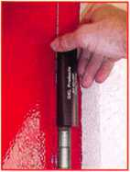

**for Life!**

**HA1 For  
Standard**

**Commercial**

**4-1/2" x 4-1/2"**

**Butt Hinges**

**HA2**

***"The HULK"***

**For Residential Hinges**

**COMING IN  
SEPTEMBER**

**HA3**

**For Ball- Bearing**

**Commercial Hinges**

**The Hinge Doctor is a great way to repair those sagging metal  
doors. Slip the tool over the hinge and open the door an inch**

**or two past the point where the tool binds against the**

**hinge, remove the tool and check the door,  
which should now be working properly.**

**If you're a locksmith these tools  
will turn a profit the 1st time you  
use them!  
Uses - schools, hospitals,**

**commercial buildings, storefronts  
with butt hinges, office doors, new**

**construction, door alignment, sagging**

**doors, jail cells, anywhere there are  
commercial grade hinges.**

**HA4**

**For Prison**

**& Institutional**

**Hinges &**

**Spring Hinges**

US Patent #6450003

**[www.hingedoctor.com](http://www.hingedoctor.com)**

**800-924-5397**

Over

10,000

Satisfied

Customers

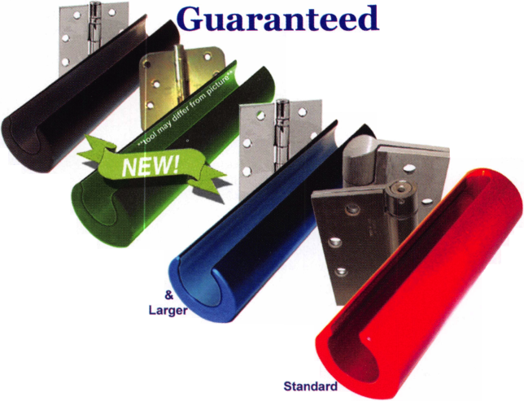

date will be made this fall to have the Senate approve leg­islation that contains the core components of the Small Business Health Fairness Act (S. 406).

The AHP bill did gain a new backer in early September when Senator Sam Brownback (R-KS) officially became a cosponsor of the bill. Senator Mike Enzi (R-WY) continues working on development of a comprehensive health insur­ance reform bill that he has indicated will include provisions for Association Health Plans. It is critical to retain the core components of S. 406, including the option of self-funding for AHPs, in Enzi's bill. It appears that Senator Enzi will cir­culate a draft in the next few weeks and then attempt to have the legislation approved by the Senate Health, Education, Labor and Pensions Committee. As soon as fur­ther information regarding the status of Senator Enzi's propos­al becomes available, members will be briefed accordingly.

Meanwhile, Senators Olympia Snowe (R-ME) and Jim Talent (R-MO) have been holding meetings with numerous Senate colleagues in order to obtain more support for S. 406 and discuss potential changes to the bill that might enable it to move forward in some form. One of the most

encouraging indications that the Senate is serious about acting on AHP legislation is that Senate Majority Leader Bill Frist (R-TN) is actively monitoring the discussions on AHPs among Senators. According to sources, Senator Frist is eager to fulfill his commitment to Senator Talent to get an AHP bill through the Senate this year.

Should a mark-up of Senator Enzi's health reform legisla­tion be scheduled, it will be important for all ALOA mem­bers to contact members of the Senate Health, Education, Labor and Pensions Committee with respect to Enzi's bill.

Tim McMullen, CAE ALOA Legislative Mananger

'LOCK SAVEi

LUBRICANT PROTECTION  
FOR ALL LOCKS

World's Finest Synthetic Lubricant

Long Lasting Lubrication & Protection

MADE IN THE USA

1S% MORE FR

'mKSAVjfy

**lubricant  
protectant  
*0R ALL LOCKS**

Environmentally Safe, Non-Toxic Will Not Gum Up or Clog Up For All Lock & Key Combinations

to

Mil-Comm Products Company, Inc.

* Will Not Attract Dirt, Water or Debris
* Works Well in All Climates
* Temperature Range: -65°F to +450°F

TOLL FREE: 800.743.4518

Visit Our New Website: [www.mil-comm.com](http://www.mil-comm.com)



Keynotes • November 2005

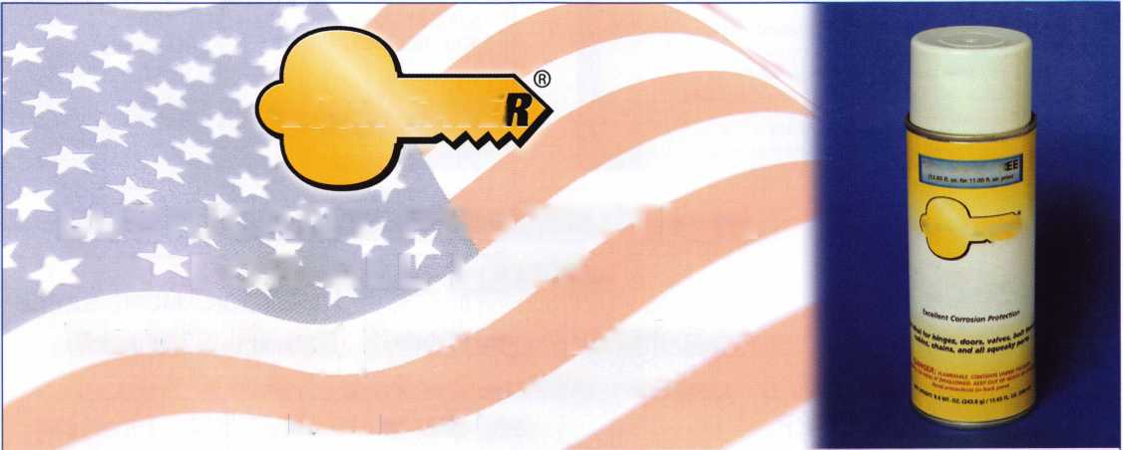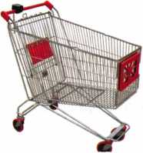

keynotes

**Buyer's**

**Marketplace**

**ADVERTISE WITH  
OUR**

**WEATHERPROOF**

**LABLES**

Professional Business Products

We offer lower prices on standard and custom  
invoices/work orders, checks, business cards,  
repair tags, key tags, magnets and much more.  
Call today for our brochure and samples.

[www.pbp2000.com](http://www.pbp2000.com)

Loops

**New!** Keedex

Stainless

Armored Door

AVAILABLE FROM YOUR KEEDEX DISTRIBUTOR

MADE IN U.S.A.

*Ideas That Work"

ALL

STAINLESS STEEL  
DESIGN

FLEXIBLE STAINLESS

STEEL CONDUIT

STAINLESS STEEL  
END PIECES

STAINLESS STEEL  
MOUNTING SCREWS

COSTS NO MORE  
THAN MOST DOOR  
LOOPS THAT HAVE  
PLASTIC END PIECES

Call or write today  
for yourfree catalog!

Keedex, Inc.

12931 Shackelford Lane  
Garden Grove, CA 92841  
714-636-5657 • Fax: 714-636-56810  
e-mail: [info@keedex.com](mailto:info@keedex.com)

[www.keedex.com](http://www.keedex.com)

|  |  |
| --- | --- |
|  | FROM A & B |
|  | SAFE CORP. |
|  | A & 6 Chest |
|  | Model WS-0 |
|  | Equipped with dual key. |
|  | combination or |
|  | electronic locking |
|  | sbt optional |
| A & B SAFE CORPORATION | |
| 171 S. Delsea Dr. | |
| Glassboro, NJ 08028-6237 | |
| 856-863-1186 | Fax 856-863-1208 |

Accept Credit Cards!

In your Locksmithing Business, Storefronts/Offices/Homebased



**No application fees**

**No Monthly Minimum**

**No Lease Requirements**

**0nsite wireless terminals available**

RETRIEVER PAYMENT

SYSTEMS

888-549-6424

IN-ST0CK...M0RE SAFEES

***FREE Freight Program***

***(30 States)***

**AMSEC** FireKing

Gardall **hayman**

MEILINK Y/CTOR.

**TURD 1©**

**WHOLESALE SERVICE**

800**-**848-9790



Keynotes • November 2005

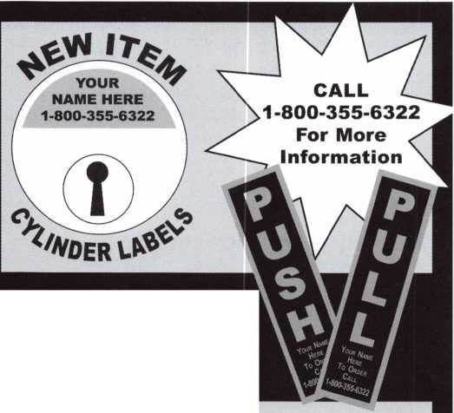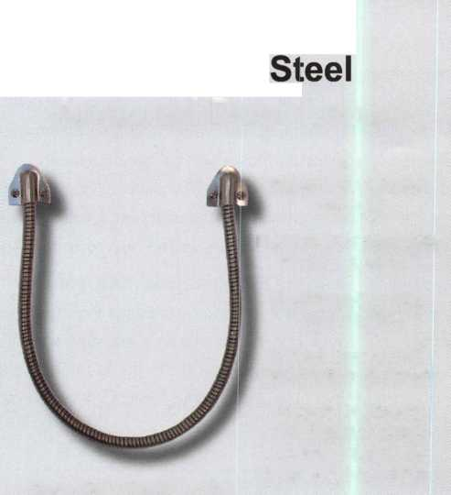

T,M.

***OPERATOR SAFETY***

Injuries can be virtually eliminated. Ultra Lift does the lift­ing so that operator effort required to complete a move is minimized. Heavy loads are broken back with ease. The operator stays in control by using a combination of motor power, balance and leverage in every phase of a move.

***REDUCE LABOR COSTS***

Fewer people are required for any move with Ultra Lift. Manpower can be scheduled more productively. Labor savings often pay for the Ultra Lift in one month.

***ELIMINATE DAMAGE***

Loads are broken back, set down and moved under power with maximum leverage and operator control. Gentle handling eliminates bumps, bounces and damage to the load and premises.

***INCREASE PROFITS***

Increased operator safety, reduced labor cost and elimina­tion of damage to the load and premises ail contribute to significant increases in profits.

FOR LITERATURE, VIDEO OR ON-SITE DEMONSTRATION, WRITE OR CALL:

ULTRA LIFT supplies the power - so you don't have to. One person can safely and easily handle loads that usually require 2 or 3 people, even up or down stairs. Two people can handle most safes to 1500 pounds. If safety is your concern, ULTRA LIFT is the best move you'll ever make!

ULTRA LIFT CORPORATION

475 STOCKTON AVENUE, UNIT E SAN JOSE, CA 95126 800-346-3057 408-287-9400 FAX 408-297-1199 E-mail: [info@uitralift.com](mailto:info@uitralift.com) [www.ultralift.com](http://www.ultralift.com)

U.S. PATENT 4.570.953

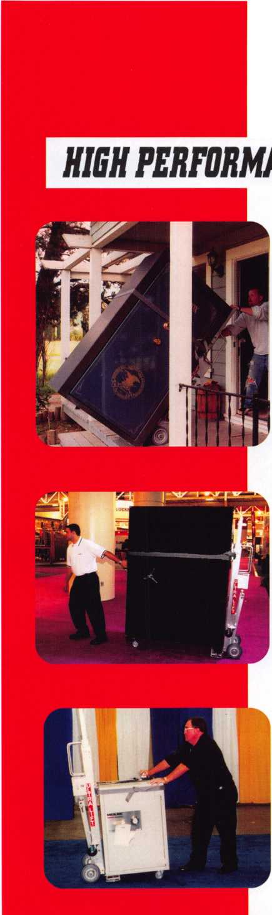

I

I

FI Visit

[www.kaba-ilco.com/vanpromt5](http://www.kaba-ilco.com/vanpromt5)  
for all the details!

**Sweepstakes is open to all professional Locksmiths & Security personnel, located in the 50 U.S., the District of Columbia & Canada (except for C  
an authorized Iko Products Distributor, who are eligible to make purchases of qualifying llco parts from authorized Iko Distributor's & wlx> art  
Void in** Quebec **& where prohibited by law. No purchase necessary For die Official Rules & for an Official Entry Form, log on to wwwkaba-ik** c  
**Products Distributor. Mail entries to: Iko “You Could Win A Trip To Vegas & Ultimate Lockshop Package* Sweepstakes. P.O. Box 222510, H** 3  
**must be postmarked by 5/17/06 and rac’d by 5/24/06.**

**uebec), who have an account withj 21 years of age or older as of 5/2406. com/vanpromo, or see your' Iko lywood, FL 33022-2510.** Entries

to your success

*ucn*

A Member of the KAB ^ Group UATtM www kaba-ilco.com

llco s “You Could Win a Trip to Vegas and Ultimate LockshoD Pac

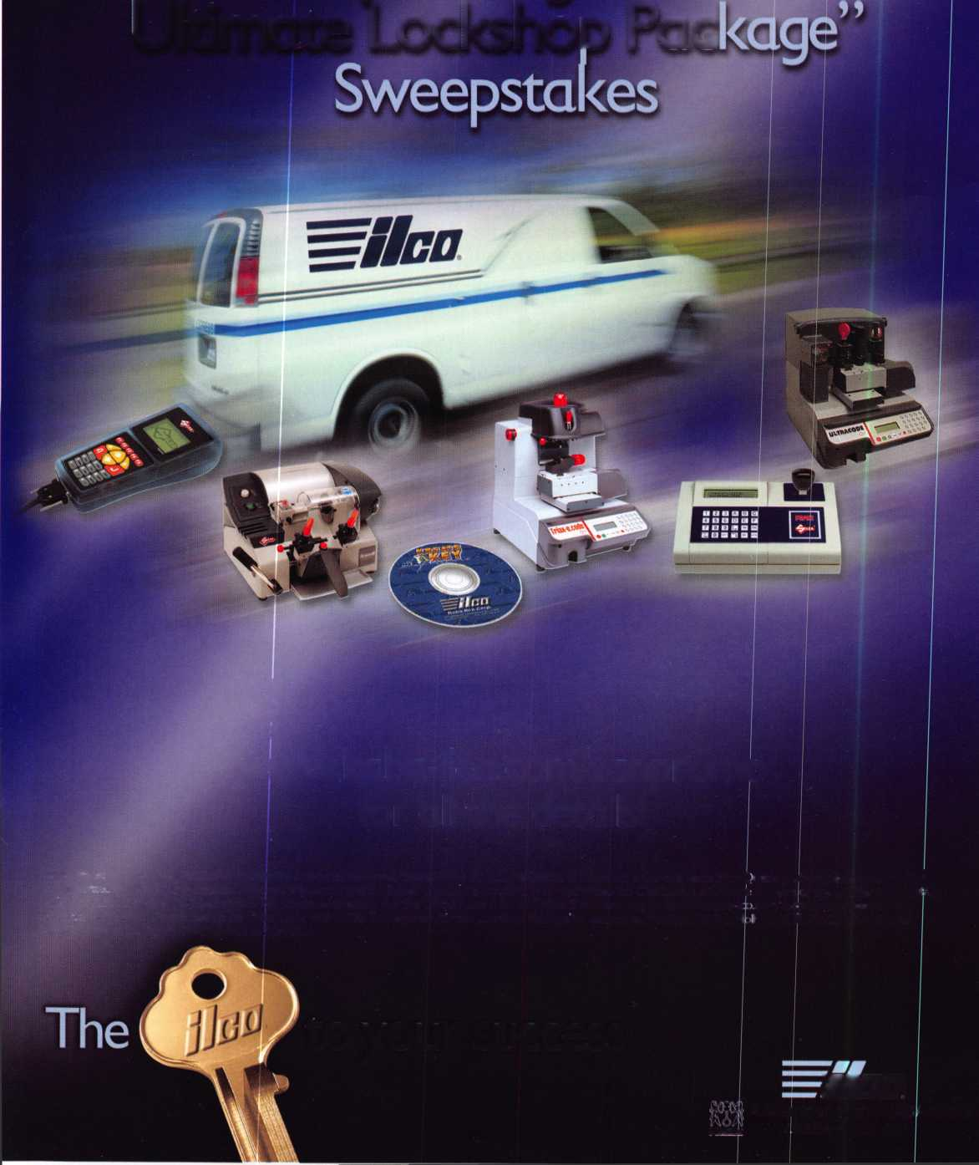

*Comfit*

Alberto, 11 years Machine Operator

SECURITY PRODUCTS

Raymond, 4 years Accounting

Shirley, 23 ye- LockAssembl

8 years ner Service

We represent the 500 employees of CompX Security Products.

Hardworking. Reliable. Dedicated.

And it shows in the products we make.

Is it any surprise that, year after year, you the locksmith community, choose to partner with us?

Made in America does matter to you, and it matters to us. Through our four US facilities, we will continue to provide you with the high quality products you have come to expect from CompX Security Products.

***Comfit***

***Comfit***

***Comfit. Comfit***

CHICAGO

TIMBERLINE

FORT

NATIONAL



JwJ

**NGS XL CAN**Locksmith 8008LXLC

NGS XL CAN Locksmith Kit 8008LXLC

* NGS XL Tester and Locksmith VIM
* NGS XL CAN VIM
* 1996-Current Model Year Ford Transponder

PATS Reprogramming Software

* FREE - 2 Additional Years of Software
* 81204 - CAN Vehicle Interface Cable
* 81205 - CAN Power Cable
* 800N - OBDII/EEC-V Cable
* HI05-00100 - Central Security Module Cable
* NGS/Locksmith/PATS Instruction Manual
* Key Blank/System Quick Reference Card
* Transponder Marketing Support Pack
* Blo-molded Carrying Case
* 13 Month Warranty

**CANCEL**

8008LXLC

CAN VIM

81201L

(SuA fit k i

NGS CAN VIM Kit 81201L

* NGS CAN Vehicle Interface Module (VIM)
* 81204 - CAN Vehicle Interface Cable
* 81205 - CAN Auxiliary Power Cable
* 2003-2005 CAN Software Card
* 2005 Non-CAN Software Cards
* Operator's Manual
* Key Blank Quick Reference Chart

81201L

**Your key to uhjocking Ford/Lincoln and Mazda**

**The most reliable unit available  
for transponder key programming  
and PATS system diagnostics on  
ALL Ford Lincoln/Mercury and  
Mazda* vehicles.**

**CAN Vehicle Interface Module ajjfoi Model Software Update now aBaiic**

*TOLL FREEnmuppm*

*800/342-5080*

